Appendix to book 3
The following group of people and their scams, have given me ideas for my books, weather reading about them, talking to them in person, or direct stories from their employees and aquatics. I have read the autobiographies of some of these characters. Several friends of mine, that since died, knew some of these people, and participated in their scams and other sins; their-* stories, about dead people, were very interesting. Of course, I take the Fifth on my activities.
The following information is mostly from Wikipedia during October 2011, with some additions in 2014. It is edited to only have the material of interest for the context of the books Las Vegas Sins and Scams by Paul Winquist.
No references are given, and the material has been seriously edited; to get the full story on each character, casino, or organization; see the original Wikipedia listing, and then click on the reference material given.
All green writing is by me. (PWW)
All photos marked Wikipedia are some sort or another of semi-copyright material; you should look up the source contracts on the Wikipedia sites before copying them.
All photos by me can be copied for non-publishing uses as long as credit is given to Paul Wallace Winquist or pwinquist.com. For commercial uses call me at 503-431-1032 or e-mail paulwinquist1945@gmail.com
Steve Wright - Serial Killer

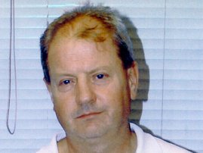

Wright's mugshot - Steve Wright, convicted murderer responsible for the 2006 Ipswich serial killings – Wikipedia

Steven Gerald James Wright (born 24 April 1958) is an English serial killer, also known as the Suffolk Strangler. He is currently serving life imprisonment for the murder of five women who worked as prostitutes in Ipswich, Suffolk. The killings took place during late 2006 and Wright was found guilty in February 2008.

Jack Binion - Ca$ino Operator
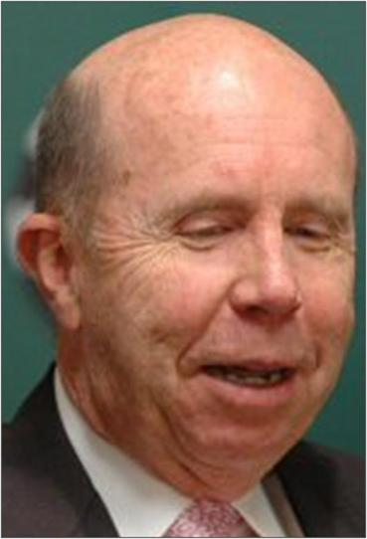
Jack Binion Date 24 May 2007
Jack Binion (born 1937) is an American ca$ino operator. Jack is the son of casino magnate Benny Binion and worked for his father at Binion's Horseshoe, a casino and hotel in Las Vegas, Nevada.
Jack became president of the Horseshoe in 1963 at the age of 26.
Jack's fame grew following his 1970 hosting of the first World Series of Poker at the Horseshoe which became the largest set of poker tournaments in the world. Privately held, Binion's Horseshoe became renowned as one of Nevada's most successful casino operations.
I n 1998, following a protracted legal battle for control of the Horseshoe among Benny Binion's heirs, Jack sold his interest in Binion's Horseshoe to his sister, Becky Behnen, while retaining a token 1% interest in the operation so that he could lawfully retain his Nevada Gaming License. He also acquired the rights to the Horseshoe brand outside of Nevada.
Jack went on to form Horseshoe Gaming Holding Corporation which developed and operated several riverboat casinos under the Horseshoe name. Jack continued to promote the casinos for Harrah's Entertainment following his sale of the company in 2004 to Harrah's. As of 2008, Binion's name appears on the "Jack Binion's Steakhouse" at Horseshoe Tunica and Horseshoe Hammond and several of the Horseshoe-branded casinos still carry slot machines bearing Binion's likeness called "Who Wants To Be A Binionaire?" that originated before the Harrah's acquisition.
While running Horseshoe Gaming, Jack started the World Poker Open which has become one of the major feeder tournaments for the World Series of Poker.
Jack was inducted into the American Gaming Association's Gaming Hall of Fame on June 11, 2004. The following year on July 6, 2005 the World Series of Poker, inducted him into the Poker Hall of Fame.
In July 2006, Jack became chairman of Wynn International. His responsibilities included opening the Wynn Macau. He has since resigned the position but has remained with Wynn Resorts in a consulting role.

Ted Binion - Ca$ino Operator
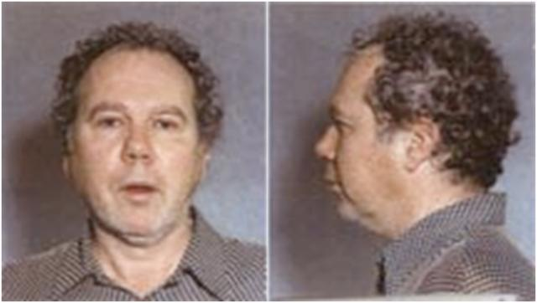
Ted Binion booking photos from the Las Vegas Metropolitan Police

Qualifies as fair use under United States copyright law.
Lonnie Theodore ‘‘Ted’’ Binion (November 28, 1943 to September 17, 1998) was a wealthy U.S. gambling executive and one of the sons of famed Las Vegas casino magnate Lester Ben ‘‘Benny’’ Binion, owner of Binion's Horseshoe. His death has been a subject of controversy; girlfriend Sandra Murphy and her lover Rick Tabish were initially charged and convicted in Binion's death, but were later granted a new trial and acquitted on the murder charges.
Ted Binion was born in Dallas in 1943. He had an older brother, Jack, and three sisters: Becky, Brenda, and Barbara. Binion moved to Las Vegas with his father in 1947. He was involved early on in his father's casino, the Horseshoe.
While growing up, Ted spent summers at the family's Montana retreat, a cattle ranch in Jordan Montana, to work with the ranch hands. Later, in the 1970s, Benny sent his three grandsons, his daughter Barbara’s sons, to Montana to run the ranch. By the 1980s, Benny had amassed an 85,000-acre (340 km2) ranch, according to the county recorder’s office. The last parcel he purchased was in 1985. The family sold all the parcels in April 1998 to John Hillenbrand.
In 1964, Benny Binion regained full control of the Horseshoe after previously selling his interest to cover his legal costs defending himself from tax evasion and other charges. Since he was a convicted criminal, Benny was no longer allowed to hold a gaming license. His sons Jack and Ted took over the day-to-day operation of the casino. Jack filled the role of president, while Ted became the casino manager.
Ted was under nearly constant scrutiny from the Nevada Gaming Commission from 1986 onwards for his involvement in drugs and associating with known mob figures. His gaming license was revoked in 1998, and he died in mysterious circumstances a few months later. Ted Binion was found dead on a small mattress on the floor of his Las Vegas estate home, 2408 Palomino Lane near Rancho Drive and Charleston Boulevard, on September 17, 1998. Empty pill bottles were found near the body, and an autopsy and toxicology report revealed that he died of a lethal dosage combination of the prescription sedative Xanax and heroin, with traces of Valium. The day before, Binion had himself purchased 12 pieces of tar heroin from a street drug dealer, and had earlier gotten a prescription from his next-door neighbor, a doctor, for Xanax, and evidence introduced at trial showed that Binion personally took the prescription to be filled at a local pharmacy.
Binion's death was initially treated as a probable suicide. His live-in girlfriend, Sandy Murphy, said that Binion had been suicidal ever since losing his gaming license a few months earlier. His sister Barbara, afflicted with the same kinds of drug problems as her brother, committed suicide in 1977, which also helped contribute to the perception that Ted could have been vulnerable to suicide as well. However, his sister Becky discounted any talk of suicide, saying that in her conversations with him that he didn't sound despondent.
Las Vegas homicide detectives suspected that the scene had been staged, as his body didn't show the typical signs of a drug overdose. Also, the stomach contained heroin and the police thought that neither an addict nor a suicide would take heroin in that manner. However, despite the urgings of Becky Behnen and Jack Binion, they refused to open a full-scale homicide investigation. Six months later, chief medical examiner Lary Simms ruled Binion had died of a heroin and Xanax overdose. After six months, however, the coroner's office reclassified Ted's death a homicide on May 5, 1999. Although there were no specifics, law enforcement sources cited evidence that the death scene had been staged, as well as witness statements implicating Murphy and Tabish. Detectives had suspected for some time that Murphy and Tabish had been romantically involved, and had learned that Binion suspected Murphy was cheating on him.
In June 1999, Sandy Murphy and Rick Tabish were arrested for Binion's murder, as well as for conspiracy, robbery, grand larceny, and burglary. The prosecution contended that Murphy and Tabish had conspired to kill Binion and steal his riches, drugging Binion into unconsciousness and burking him, a form of manual suffocation. The suffocation, in this theory, was done because the overdose was taking too long, and the pair feared discovery. They were each charged with murder and burglary charges connected to the removal of his fortune from the vault on the desert floor in Pahrump.
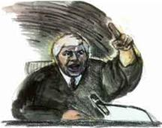
Courtroom artist, Paulette Frankl sketched this image of Judge Joseph Bonaventure during the Binion trial

Wikipedia

Steve Winn - Casino Owner +++
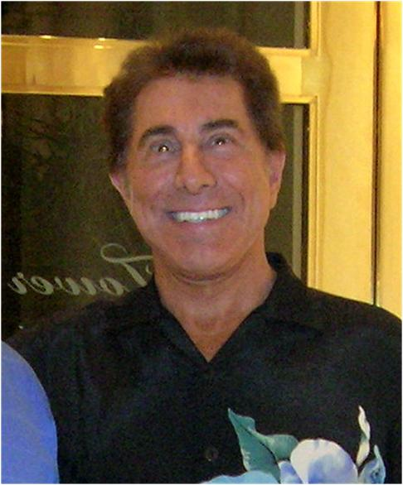
Stephen Alan "Steve" Wynn (born: Stephen Alan Weinberg) (born January 27, 1942) is an American business magnate who played a pivotal role in the 1990s resurgence and expansion of the Las Vegas Strip. His companies refurbished or built what are now widely recognized resorts in Las Vegas, including the Golden Nugget, the Mirage, Treasure Island, Bellagio, Wynn, and Encore.
As of 2011, Wynn is the 512th richest man in the world with a net worth of $2.3 billion (up from $1.5 billion). He made his debut in the Forbes 400 at #377 with a net worth of $650 million in September 2003, but was reported to be worth $1.1 billion only six months later in Forbes' list of world billionaires published in March 2004. Religion - Judaism
In April 2010, Wynn caused a stir when he chided the government on CNBC and said he was considering moving the company's global headquarters from Las Vegas to Macau. A few weeks later, amidst criticism from his rivals, he clarified that he meant a greater allocation of time spent in Macau because of the substantially higher profits made there.
Early life, Frontier, and the Golden Nugget:
Wynn was born Stephen Alan Weinberg in New Haven, Connecticut. His father, Michael, changed the family's last name in 1946 from "Weinberg" to "Wynn" when Steve was six months old "to avoid anti-Jewish discrimination" according to several sources.
Wynn's father ran a string of bingo parlors in eastern United States. In 1963, his father died of complications from open heart surgery in Minneapolis, leaving $350,000 of gaming debts, shortly before Wynn graduated from Penn with a Bachelor of Arts degree in English Literature.
Wynn took over running the family's bingo operation in Maryland. He did well enough at it to accumulate the money to buy a small stake in the Frontier Hotel and Casino in Las Vegas, where he and his wife Elaine moved in 1967. Between 1968 and 1972 Wynn also owned a wine and liquor importing company. He managed to parlay his profits from a land deal in 1971 (the deal involved Howard Hughes and Caesars Palace) into a controlling interest in the landmark downtown casino, the Golden Nugget Las Vegas (he also owned Golden Nugget Atlantic City in Atlantic City, New Jersey). Wynn renovated, revamped, and expanded the Golden Nugget from a gambling hall to a resort hotel and casino with enormous success, in the process attracting a new upscale clientele to downtown Las Vegas.
The Mirage, Treasure Island, and Bellagio:
Wynn had previously acquired interests in various existing casinos. His first major Strip casino, the Mirage, which opened in 1989, set a new standard for size, opulence, and construction costs. The Mirage featured an indoor forest and an outdoor "volcano"; and with high-quality room appointments and an emphasis on service, the Mirage was another major success. The Mirage was the first project in which he was involved in the design and construction of a casino. The $630 million cost to build the facility was financed largely with junk bonds issued by Michael Milken. The property was considered a high-risk venture by the standards then prevailing in Las Vegas because of its expensiveness and emphasis on luxury. However, it became enormously lucrative and made Wynn a major part of Las Vegas history.
Wynn's next project was Treasure Island Hotel and Casino, which opened in 1993 at a cost of $450 million. With its live pirate show and location next to the Mirage, Treasure Island was another victory for Wynn. The Cirque du Soleil show at the Treasure Island was the first permanent Cirque du Soleil show in Las Vegas. (I worked on this construction project on sound system wiring. Steve walked through the project many times, and was a friendly owner getting along good with the contractors, unlike Sheldon Adelson)
Wynn expanded further on his concept of the luxury casino with Bellagio, a $1.6 billion resort, including an artificial lake, indoor conservatory, a museum-quality art gallery and branches of high-end boutiques and restaurants from Paris, San Francisco, and New York City. The architect was the famous American Jon Jerde of The Jerde Partnerships. When built, Bellagio was the most expensive hotel in the world. The Bellagio is credited with starting a new spree of luxurious developments in Las Vegas. Among these developments include The Venetian, Mandalay Bay, and Paris Las Vegas.
Beau Rivage:
He also designed and built a luxury resort, the Beau Rivage, in Biloxi. Beau Rivage was originally the name he wanted to give to the Bellagio. He then went to Italy on vacation and decided Bellagio was a better name for the hotel.
Wynn Las Vegas to Wynn Macau to present and Encore:
Mirage Resorts was sold to MGM Grand Inc. for $6.6 billion ($21 a share), in June 2000 to form MGM Mirage. Five weeks before the deal was closed (April 27, 2000) Steve Wynn purchased the Desert Inn for $270 million. He closed the Inn in only 18 weeks, and with the money he made on that deal, and with his ability to secure ever-greater financing, Steve Wynn took Wynn Resorts Limited public in 2002. Wynn became a billionaire in 2004, when his net worth doubled to $1.3 billion. On April 28, 2005 he opened his most expensive resort to that date, the Wynn Las Vegas, on the site of the former Desert Inn.
Wynn successfully bid for one of three gaming concessions that were opened for tender in Macau, a Special Administrative Region (SAR) of China, which has a long history of gaming and is the largest gaming market in the world, having surpassed Las Vegas in 2006. This property, known as Wynn Macau, opened on September 5, 2006.
In the summer of 2008, hiring began for Encore Las Vegas, the newest in Steve Wynn's collection of resorts (the tower of Encore is modeled after the Wynn Las Vegas tower, and in fact, they share the same "property" though they are separate hotels). Wynn hired 3500 employees for this property. Encore opened on December 22, 2008.
Wynn Encore Macau opened on April 21, 2010.
Recently he spent a record price for a painting by J. M. W. Turner, $35.8 million for the Giudecca, La Donna Della Salute and San Giorgio, and spent $33.2 million on a Rembrandt, the auction record for the artist.
Many of the collection's pieces were on display at the Bellagio. The collection was on display at the Nevada Museum of Art in Reno while the Wynn Las Vegas was being constructed and was installed in the resort shortly before it was opened. The Wynn Las Vegas gallery, which had charged an entrance fee, closed shortly after the start of 2006. The artwork from the former gallery is now scattered around the resort. Although the artwork is owned personally by Wynn, Wynn Resorts pays an annual lease of $1. As part of the lease agreement, insurance and security are the responsibility of the company.

Sheldon Adelson - Super Greedy Scammer
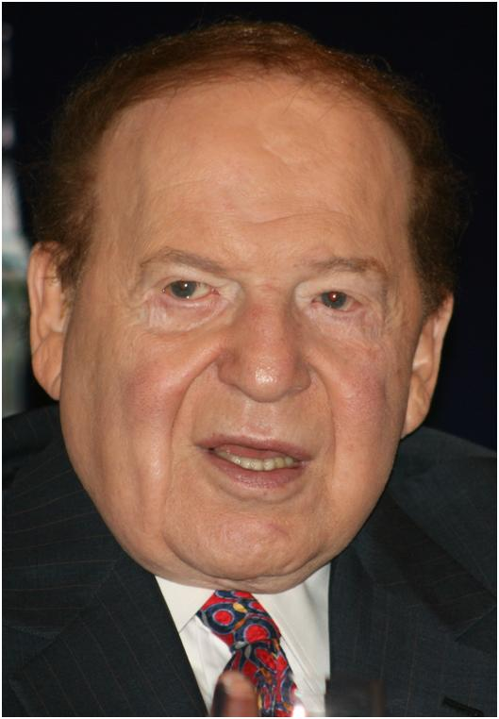
Sheldon Gary Adelson (born August 6, 1933) is an American casino magnate. Adelson is Chairman and Chief Executive Officer of the Las Vegas Sands Corp., the parent company of Venetian Macao Limited which operates The Venetian Resort Hotel Casino and the Sands Expo and Convention Center. Adelson vastly increased his net worth upon the initial public offering of Las Vegas Sands in December 2004. He is currently the 8th wealthiest American and 16th wealthiest person in the world, with a net worth of $21.5 billion.
Originally a Democrat, Adelson became a Republican, as his wealth increased. "Why is it fair that I should be paying a higher percentage of taxes than anyone else?" he once asked. He began making major contributions to the Republican National Committee following clashes with labor unions at his Las Vegas properties
COMDEX and casinos:
The original source of Adelson's wealth and current investments was the computer trade show COMDEX, which he and his partners developed for the computer industry; the first show was in 1979. It was the premier computer trade show through much of the 1980s and 1990s.
In 1988, Adelson and his partners purchased the Sands Hotel and Casino in Las Vegas, Nevada, the former hangout of Frank Sinatra and the Rat Pack, in order to bring Las Vegas to a new phase of business through the exhibition industry. The following year, Adelson and his partners constructed the Sands Expo and Convention Center, then, the only privately owned and operated convention center in the United States.
In 1991, while honeymooning in Venice with his second wife, Miriam, Adelson said he found the inspiration for a mega-resort hotel. He razed (by implosion) the Sands and spent $1.5-billion to construct the The Venetian, a Venice-themed resort hotel and casino. The luxurious, all-suite Venetian revolutionized the Las Vegas hotel industry, and has been honored with architectural and other awards naming it as one the finest hotels in the world. In 2003, The Venetian added the 1,013-suite Venezia tower - giving The Venetian 4,049 suites, 18 leading-chef restaurants, a shopping mall with canals, gondolas and singing gondoliers.
In 1995, Adelson and his partners sold the Interface Group Show Division, including the COMDEX shows, to SoftBank Corporation of Japan for $862 million; Adelson's share was over $500 million.
Adelson spearheaded a major project to bring the Sands name to the Macao SAR, China, the Chinese gambling city that was a Portuguese colony until December 1999. The one million-square-foot Sands Macau became the People's Republic of China's first Las Vegas-style casino when it opened in May 2004. Adelson made back his initial 265 million dollar investment in one year and, because he owns 69% of the stock, he increased his wealth when he took the stock public in December 2004. Since the opening of the Sands Macao Adelson's personal wealth has multiplied more than fourteen times.
In May 2006, Adelson's Las Vegas Sands was awarded a hotly contested license to construct a casino resort in Singapore's Marina Bay. The new casino, Marina Bay Sands, opened in 2010 at a rumored cost of US$5.4 billion.
In August 2007, Adelson opened the $2.4 billion Venetian Macao Resort Hotel on Cotai and announced that he planned to create a massive, concentrated resort area he called the Cotai Strip, after its Las Vegas counterpart. Adelson said that he planned to open more hotels under brands such as Four Seasons, Sheraton and St. Regis. His Las Vegas Sands plans to invest $12 billion and build 20,000 hotel rooms on the Cotai Strip by 2010.
In 2007, Adelson made an unsuccessful bid to purchase the Israeli newspaper Maariv. When this failed, he proceeded with parallel plans to publish a free daily newspaper to compete with Israeli, a newspaper he had co-founded in 2006 but had left. The first edition of the new newspaper, Israel HaYom, was published on July 30, 2007.

Oscar Goodman - Lawyer and Mayor of Las Vegas
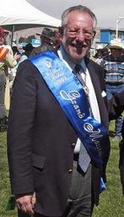
Oscar Baylin Goodman (born July 26, 1939) is an American lawyer and politician. He was the mayor of Las Vegas, Nevada from 1999 to 2011. Mayor Goodman is an Independent and a former member of the Democratic Party.
Goodman was born to a Jewish family in Philadelphia, Pennsylvania
During his career as a defense attorney he represented defendants accused of being some of the leading organized crime figures in Las Vegas, such as Meyer Lansky, Nicky Scarfo, Herbert "Fat Herbie" Blitzstein, Phil Leonetti, former Stardust Casino boss Frank 'Lefty' Rosenthal, and Jamiel "Jimmy" Chagra a 1970s drug trafficker who was acquitted of ordering the murder of Federal Judge John H. Wood, Jr. His most notorious client was reputed Chicago mobster Anthony "Tony the Ant" Spilotro, who was known to have a short and violent temper. In the semi-factual 1995 movie Casino, the character of Nicky Santoro was based on Spilotro and was portrayed by actor Joe Pesci. Goodman had a cameo appearance in the film as himself while defending "Ace Rothstein", which was a character closely based on Lefty Rosenthal and played by Robert DeNiro. Goodman also represented former San Diego Mayor Roger Hedgecock, who was convicted of accepting illegal campaign contributions and eventually forced to resign; Hedgecock was later cleared of all charges on appeal.
Goodman was a senior partner in the law firm of Goodman and Chesnoff. Goodman currently serves as Of Counsel to Goodman Law Group, a Las Vegas law firm formed by his son, Ross C. Goodman. Goodman was elected mayor of Las Vegas on June 8, 1999; receiving 32,765 (63.76 percent) votes while his opponent, then-Las Vegas City Councilman Arnie Adamsen, received 18,620 (36.24 percent). Goodman was re-elected to a second four-year term in 2003, defeating five opponents and receiving 29,356 (85.72 percent) of the votes. On April 3, 2007, he was re-elected to a third and final term with 26,845 votes (83.69 percent), again defeating five opponents. Las Vegas law prevents the mayor, who has been called the town's "most popular mayor", from serving more than three terms.
(The Federal Government donated the ancient post office to the city and they made a gangster museum out of it).
(Oscar Goodman was my neighbor in the Las Vegas Scotch Eighties neighborhood; he personally answers the door for trick-or-treaters on Halloween, so you know he has no serious enemies. PWW)

Doug Da Silva - Super Real Estate Scammer and Losing Gambler
I did business with Doug; he is a pathological liar, bad check writer, loosing gambler, and gay hotel owner, swindling many investors with his hotel purchasing and reselling scams. He purchased the remaining parts of the old Thunderbird hotel from Bob Stupak and split it into three worthless hotels, making a huge profit that he gambled away.
There are many stories about him in the Review Journal in Las Vegas and the papers in El Paso; he is in the news lately about his scams at the Artisan Hotels in Las Vegas and El Paso. He has (2011) bankruptcy filings in U.S. Bankruptcy Court in Las Vegas; Da Silva owes more than $25 million - including almost $11.5 million to investors who lent him money to open at least one of the Artisan hotels.
When Doug purchased the old Thunderbird buildings from Bob Stupak, bob left some coins and rocks, supposedly from the moon, in the huge safe, with the agreement that Bob had 90 days to get the stuff moved. On the 89th day Bobs crew of security guards came to get the stuff; Doug told them, “…I don’t have time to deal with it today; come back tomorrow…” the next day when they returned Doug said, “…You waited too long; the stuff is mine now…”; he got charged with extortion over that matter, and it made the news. A few days later, I was trying to get a check from the illusive Doug; I slipped up the stairs to his office and he started to write the check. I said, “I can’t believe that you tried to scam one of the old original mobsters, and you are still alive.” The first part of the check was with good penmanship, but the numbers part was just nervous scribble. The month later, when I went to get a check, he had moved into a very secure office with a bulletproof door.
About 3:00 in the morning, I was staying in what was called the Vegas Hotel at the time, now it’s the Artisan; the fire alarm started ringing constantly. After about five munities, I called down to the front desk and asked, “When are they going to shut off the fire alarm?” The reply was, “Ahhhh, I guess when they put out the fire”. I was in the third building over from the main building and walked out to the balcony to see what was up, and noticed a very small fire coming out of the air handling equipment on the roof of the main building; a fireman could have pissed it out at this point; or killing the power probably would have let it go out. About ten minutes later a group of fire trucks arrived along with a huge fire command center motor home type vehicle. The fire continued to grow as the firefighters evacuated the building for about ten minutes. I had gone down to the parking lot to observe the situation and struck up a conversation with another customer that was staying in the end room to the left on the top floor; he said, “…Those idiots are going to let the whole building burn down; shit; my keys and wallet are up there”; he made a mad dash for the stairwell and a fireman tackled him like a football player. He was pissed; as he watched, the bungling firefighters not put a drop of water in the building until the entire top floor was burning. Notice how the power is still on as the building is burning; Jewish lightning?
After the hotel was shut down for several years, Doug purchased it and quickly sold off the two good buildings and used the proceeds to renovate the main building into the gay Artisan Hotel. Of course, he gambled away the profits and went. After the hotel was shut down for several years, Doug purchased it and quickly sold off the two good buildings and used the proceeds to renovate the main building into the gay Artisan Hotel. Of course, he gambled away the profits and went bankrupt.
Doug has an air-conditioned doghouse for his guard dogs. (PWW-2011)
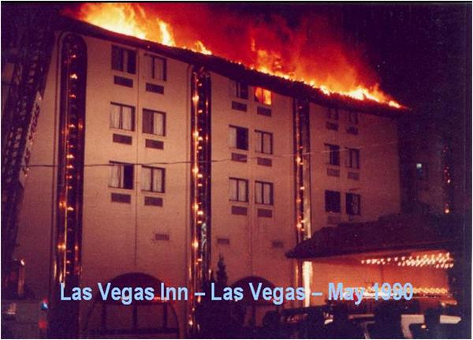

Photo by Paul Winquist

Jake Bernstein - Bullshit Artist
Jake Bernstein is President of Network Press, Inc. in Santa Cruz, California. Bernstein claims expertise in seasonal trading and has developed methods of trading in futures markets, and has been a featured speaker at many investment conferences and trading seminars. His work is controversial in that many analysts claim that his methods do not, in fact, make money.
Bernstein is publisher of the "Jake Bernstein Weekly Futures Trading Letter," "Bernstein on Stocks," "The Letter of Long-Term Trends, and "COT” Analysis". Jake Bernstein has written more than 42 books and research studies on futures trading, stock trading, trader psychology, and economic forecasting. Articles by Bernstein have appeared in Futures Magazine, Money Maker, Stocks and Commodities, Barron’s Financial Weekly, Stocks, Futures and Options Magazine, and FarmFutures.
Criticism:
Some sources dispute the effectiveness of Bernstein's methods. According to William Green of Forbes magazine, "Commodity Traders Consumer Report, a respected futures publication, tracks the trades Bernstein recommends in his $895 flagship newsletter. If you had acted on these weekly tips from 1988 through 1992, you would have lost money for five consecutive years (assuming typical transaction costs)."
In 1996, the Business Conduct Committee of the National Futures Association charged MBH and Bernstein for using misleading and deceptive promotional materials in an infomercial. The NFA also charged that "MBH and Bernstein engaged in deceptive and misleading sales solicitations" and that their customers all either lost money on their trades or failed to realize the returns they claimed in the infomercial during the time the infomercial aired. Finally, they charged that the infomercial and web site falsely stated that Bernstein was a successful trader, when in fact, according to figures provided by Bernstein, the NFA's analysis showed that the account had lost $3,286.33 during 1992, $8,499.13 during 1993, $1,793.82 during 1994, $14,300.26 during 1995, and $8,374.34 during the first 11 months of 1996.
Following an unsuccessful appeal to the NFA Appeals Committee, Bernstein and MBH brought their case to the Commodity Futures Trading Commission (CFTC or Commission), which summarily affirmed the NFA's findings. As a sanction, the NFA expelled Jake Bernstein, fined his companies $200,000, and charged him for “Using misleading promotional material”, “making false profit claims”, and “downplaying the risk involved in trading”. This decision was subsequently confirmed by the United States Court of Appeals for the Seventh Circuit.
In response to his critics, Bernstein characterized the NFA hearing as a "Kangaroo court."
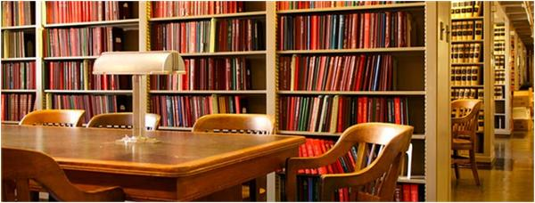

DOJ Photo

George Soros - Number One Greedy Money Trader
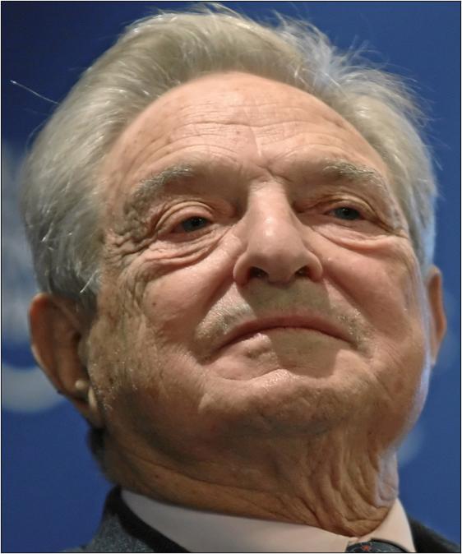
George Soros, Chairman, Soros Fund Management, USA, captured during the session 'Rebuilding Economics' of the Annual Meeting 2010 of the World Economic Forum in Davos, Switzerland, January 27, 2010 at the Congress Centre. - by Sandstein (talk)

This file is licensed under the Creative Commons Attribution-Share Alike 2.0 Generic license.
Early life:
Soros was born in Budapest, Kingdom of Hungary, the son of the Esperantist writer Tivadar Soros and Elizabeth Soros. Tivadar (also known as Teodoro) was a Hungarian Jew, who was a prisoner of war during and after World War I and eventually escaped from Russia to rejoin his family in Budapest. Tivadar taught George to speak Esperanto from birth. Soros later said that he grew up in a Jewish home and that his parents were cautious with their religious roots. Soros was thirteen years old in March 1944 when Nazi Germany occupied Hungary. Soros took a job with the Jewish Council, which had been established during the Nazi occupation of Hungary to carry out Nazi and Hungarian government anti-Jewish measures; Soros later described this time to writer Michael Lewis: “The Jewish Council asked the little kids to hand out the deportation notices. I was told to go to the Jewish Council. And there I was given these small slips of paper. . .It said report to the rabbi seminary at 9 am. . .And I was given this list of names. I took this piece of paper to my father. He instantly recognized it; this was a list of Hungarian Jewish lawyers. He said, "You deliver the slips of paper and tell the people that if they report they will be deported."
Soros emigrated to England in 1947 and, as an impoverished student, lived with his uncle, an Orthodox Jew. His uncle paid his living expenses while he attended the London School of Economics, where he received a Bachelor of Science in Philosophy in 1952.
Emigration:
In 1956, Soros moved to New York City, where he worked as an arbitrage trader with F. M. Mayer (1956 - 59) and as an analyst with Wertheim and Co. (1959 - 63). Throughout this time, Soros developed a philosophy of reflexivity based on the ideas of Karl Popper. Reflexivity, as used by Soros, is the belief that the action of beholding the valuation of any market, by its participants, affects said valuation of the market in a procyclical "virtuous or vicious" circle.
Soros realized, however, that he would not make any money from the concept of reflexivity until he went into investing on his own. He began to investigate how to deal in investments. From 1963 to 1973, he worked at Arnhold and S. Bleichroder, where he attained the position of Vice-President. Soros finally concluded that he was a better investor than he was a philosopher or an executive. In 1967, he persuaded the company to set up First Eagle, an offshore investment fund for him to run; and, in 1969, it founded the Double Eagle hedge fund for him.
In 1973, when investment regulations restricted his ability to run the funds as he wished, he resigned his position and established a private investment company, which evolved into the Quantum Fund. He has stated that his intent was to earn enough money on Wall Street to support himself as an author and philosopher - he calculated that $500,000 after five years would be possible and adequate.
In 1970, Soros founded Soros Fund Management and became its Chairman with the firm's day-to-day operations being managed by Soros's two elder sons and the firm's Chief Investment Officer Keith Anderson. In August 2010, Soros bought a 4 per cent stake in the Bombay Stock Exchange (BSE) for about $35 million.
In July 2011, Soros announced that he had returned funds from outside investors money (valued at $1 billion) and instead invested funds from his $24.5 billion family fortune due to U.S. Securities and Exchange Commission disclosure rules.
On September 16, 1992, Black Wednesday, Soros's fund sold short more than $10 billion in pounds, profiting from the UK government's reluctance to either raise its interest rates to levels comparable to those of other European Exchange Rate Mechanism countries or to float its currency.
Finally, the UK withdrew from the European Exchange Rate Mechanism, devaluing the pound, earning Soros an estimated $1.1 billion. He was dubbed "The man who broke the Bank of England". In 1997, the UK Treasury estimated the cost of Black Wednesday at £3.4 billion.
On Monday, October 26, 1992, The Times quoted Soros as saying: "Our total position by Black Wednesday had to be worth almost $10 billion. We planned to sell more than that. In fact, when Norman Lamont said just before the devaluation that he would borrow nearly $15 billion to defend sterling, we were amused because that was about how much we wanted to sell."
In 1997, during the Asian financial crisis, the Prime Minister of Malaysia Mahathir bin Mohamad accused Soros of using the wealth under his control to punish the Association of Southeast Asian Nations (ASEAN) for welcoming Myanmar as a member. Following on a history of antisemitic remarks, Mahathir made specific reference to Soros's Jewish background ("It is a Jew who triggered the currency plunge") and implied Soros was orchestrating the crash as part of a larger Jewish conspiracy. Nine years later, in 2006, Mahathir met with Soros and afterwards stated that he accepted that Soros had not been responsible for the crisis.
New York Times columnist Paul Krugman is critical of Soros's effect on financial markets. "Nobody who has read a business magazine in the last few years can be unaware that these days there really are investors who not only move money in anticipation of a currency crisis, but actually do their best to trigger that crisis for fun and profit. These new actors on the scene do not yet have a standard name; my proposed term is 'Soroi.'" (Mine is Greedy Assholes PWW)
I'm only rich because I know when I'm wrong. . . I basically have survived by recognizing my mistakes.
In February 2009, Soros said the world financial system had effectively disintegrated, adding that there was no prospect of a near-term resolution to the crisis; "We witnessed the collapse of the financial system[. . .] It was placed on life support, and it's still on life support. There's no sign that we are anywhere near a bottom."
Insider trading conviction:
In 1988 Soros was interested in purchasing shares in French companies. The Socialist party had lost its majority of seats in the Assembly, and the new government under Chirac had instituted an aggressive privatization program. Many people considered shares in the newly privatized companies undervalued. During this period, a French financier named Georges Pebereau contacted one of Soros’ advisors in an effort to assemble a group of investors to purchase a large amount of shares in Societe Generale, a leading French bank that was part of the program.
The advisor reported to Soros that Pebereau's plan was ambiguous and included an implausible takeover plan (it would indeed fail). On that advice, and without ever meeting the financier, Soros decided against participating. He did, however, move forward with his strategy of accumulating shares in four French companies: Societe Generale, as well as Suez, Paribas and the Compagnie Generale d’Electricite.
In 1989, the Commission des Operations de Bourse (the French stock exchange regulatory authority) conducted an investigation of whether Soros' transaction in Societe Generale should be considered insider trading. Soros had received no information from the Societe Generale, and had no insider knowledge of the business, but he did possess knowledge that a group of investors was planning a takeover attempt. The COB concluded that the statutes, regulations and case law relating to insider trading did not clearly establish that a crime had occurred, and that no charges should be brought against Soros.
Several years later, a Paris-based prosecutor reopened the case against Soros and two other French businessmen, disregarding the COB's findings. This resulted in Soros' 2005 conviction for insider trading by the Court of Appeals (he was the only one of the three to receive a conviction). The French Supreme Court confirmed the conviction on June 14, 2006, but reduced the penalty to the minimum.
Punitive damages were not sought because of the delay in bringing the case to trial. Soros denied any wrongdoing, saying news of the takeover was public knowledge, and it was documented that his intent to acquire shares of the company predated his own awareness of the takeover.
His insider trading conviction was upheld by the highest court in France on June 14, 2006. In December 2006, he appealed to the European Court of Human Rights on various grounds including that the 14-year delay in bringing the case to trial precluded a fair hearing. On the basis of Article 7 of the European convention on human rights, stating that no person may be punished for an act that was not a criminal offense at the time that it was committed, the Court agreed to hear the appeal. In October 2011, the court rejected his appeal in a 4 - 3 decision, saying that Soros has been aware of the risk of breaking insider trading laws.
He received honorary doctoral degrees from the New School for Social Research (New York), the University of Oxford in 1980, the Corvinus University of Budapest, and Yale University in 1991. Soros also received the Yale International Center for Finance Award from the Yale School of Management in 2000 as well as the Laurea Honoris Causa, the highest honor of the University of Bologna in 1995.
Soros played a role in the peaceful transition from communism to capitalism in Hungary (1984 - 89) and provided Europe's largest-ever higher education endowment to Central European University in Budapest. Later, the Open Society Institute's programs in Georgia were considered by Russian and Western observers to have been crucial in the success of the Rose Revolution.
In the United States, he donated large sums of money in an effort to defeat President George W. Bush's bid for re-election in 2004. In 2010, he donated $1 million in support of Proposition 19, which would have legalized marijuana in the state of California. He was an initial donor to the Center for American Progress, and he continues to support the organization through the Open Society Foundations.
In an interview with The Washington Post on November 11, 2003, Soros said that removing President George W. Bush from office was the "central focus of my life" and "a matter of life and death." He said he would sacrifice his entire fortune to defeat President Bush, "If someone guaranteed it." Soros gave $3 million to the Center for American Progress, $2.5 million to MoveOn.org, and $20 million to America Coming Together. These groups worked to support Democrats in the 2004 election. On September 28, 2004 he dedicated more money to the campaign and kicked off his own multi-state tour with a speech: Why We Must Not Re-elect President Bush, delivered at the National Press Club in Washington, DC. The online transcript to this speech received many hits after Dick Cheney accidentally referred to FactCheck.org as "factcheck.com" in the Vice Presidential debate, causing the owner of that domain to redirect all traffic to Soros's site. Asked in 2006 about his statement in The Age of Fallibility that "The main obstacle to a stable and just world order is the United States", Soros responded "It happens to coincide with the prevailing opinion in the world; and I think that's rather shocking for Americans to hear. The United States sets the agenda for the world; and the rest of the world has to respond to that agenda. By declaring a 'war on terror' after September 11, we set the wrong agenda for the world… when you wage war, you inevitably create innocent victims."
On October 26, 2010, Soros donated $1 million, the largest donation in the campaign, to the Drug Policy Alliance to fund Proposition 19, which would have legalized marijuana in the state of California, if it had passed in the November 2, 2010 elections.
Soros has funded worldwide efforts to promote drug policy reform. In 2008, Soros donated $400,000 to help fund a successful ballot measure in Massachusetts known as the Massachusetts Sensible Marijuana Policy Initiative which decriminalized possession of less than 1 oz (28g) of marijuana in the state. Soros has also funded similar measures in California, Alaska, Oregon, Washington, Colorado, Nevada, and Maine. Among the drug decriminalization groups that have received funding from Soros are the Lindesmith Center and Drug Policy Foundation. Soros donated $1.4 million to publicity efforts to support California's Proposition 5 in 2008, a failed ballot measure that would have expanded drug rehabilitation programs as alternatives to prison for persons convicted of non-violent drug-related offenses.
In October 2010, Soros donated $1 million to support California's Proposition 19.
According to remarks in an interview in October 2009, it is Soros's opinion that marijuana is less addictive but not appropriate for use by children and students. He himself has not used marijuana for years.
Despite working as an investor and currency speculator, he argues that the current system of financial speculation undermines healthy economic development in many underdeveloped countries (Because of scammers like Soros himself). Soros blames many of the world's problems on the failures inherent in what he characterizes as market fundamentalism. His opposition to many aspects of globalization has made him a controversial figure.
Soros claims to draw a distinction between being a participant in the market and working to change the rules that market participants must follow. (Yes the rules need to be changed to eliminate currency trading: a one world currency!!! PWW)
In an interview regarding the late-2000s recession, Soros referred to it as the most serious crisis since the 1930s. According to Soros, market fundamentalism with its assumption that markets will correct themselves with no need for government intervention in financial affairs has been "some kind of an ideological excess". In Soros' view, the markets' moods - a "mood" of the markets being a prevailing bias or optimism/pessimism with which the markets look at reality - "Actually can reinforce themselves so that there are these initially self-reinforcing but eventually unsustainable and self-defeating boom/bust sequences or bubbles".
In reaction to the late-2000s recession, he founded the Institute for New Economic Thinking in October 2009. This is a think tank composed of international economic, business and financial experts, mandated to investigate radical new approaches to organizing the international economic and financial system.
Views on China:
Soros has expressed concern about the growth of Chinese economic and political power. "China has risen very rapidly by looking out for its own interests . . . They have now got to accept responsibility for world order and the interests of other people as well.” Regarding the political gridlock in America, he said, "Today China has not only a more vigorous economy, but actually a better functioning government than the United States.”
Wealth:
On September 21st 2011, Forbes announced that Soros, at 81, has for the first time made the list of the 10 wealthiest Americans, with a net worth estimated at $22.0 billion. According to this list, Soros is the 46th richest person in the world. Soros has given away $8 billion to various causes since 1979.
(Think about the millions of people that contributed to his wealth through his ruthless financial manipulations/scams. His $8 billion in good donations won’t get him into some kind of heaven. PWW 2011)
Here is a guy that could afford a million of the finest rent-a-girls on the face of the earth; but, I bet the fucker’s dick doesn’t work any more.
So; what good is it to be so greedy, ruining countries money and getting massive amounts of money by squeezing it out of people’s retirement funds.
Someone needs to go around and kill about fifty of the world’s greediest ass holes; too bad I don’t have the resources to do it. Then donate their money to the Social Security Fund of that particular country, so it will benefit the real people.
Someone in my fiction book is scamming some of the scammers, in book 10.
PWW 2011

Carlos Slim - World’s Most Greedy Price Gouger
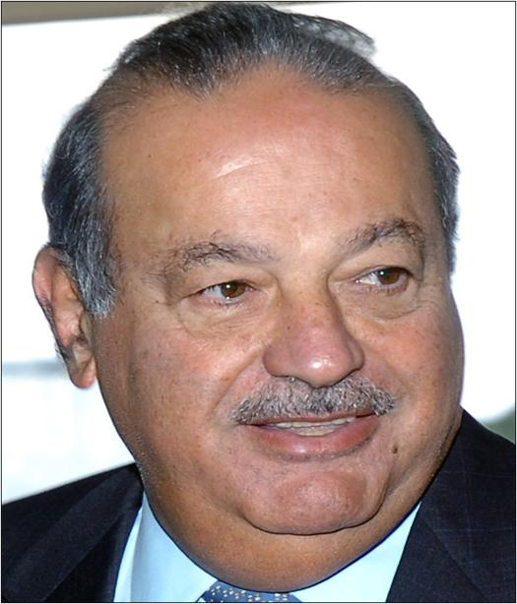
Mexican businessman Carlos Slim Helu - 24 October 2007

- This photograph was produced by Agencia Brasil, a public Brazilian news agency
Slim and his siblings were taught basic business practices by their father, and at the age of 12 Slim bought shares in a Mexican bank. He went on to study engineering at the National Autonomous University of Mexico, while simultaneously teaching algebra and linear programming there. In 1965 he incorporated Inversora Bursatil and then bought Jarritos del Sur. In 1966, already worth US$40 million, he founded Inmobiliaria Carso. Three months later he married Soumaya Domit Gemayel (the Carso name derives from the first three letters of Carlo and the first two of Soumaya) and they remained married until her death in 1999.
Construction, real estate, and mining businesses were the focus of his early career; by 1972 he had established or acquired a further seven businesses in these categories, including one which rented construction equipment. In 1976 he branched out by buying a 60% interest in a printing business, and in 1980 he consolidated his business interests by forming Grupo Galas as the parent company of a conglomerate that had interests in industry, construction, mining, retail, food and tobacco.
In 1990 the Grupo Carso was floated as a public company, with share placements initially in Mexico and then worldwide.
Later in 1990 he acted in concert with France Telecom and Southwestern Bell Corporation in order to buy landline telephony company Telmex from the Mexican government. By 2006, 90 percent of the telephone lines in Mexico are operated by Telmex, whilst his mobile telephony company, Telcel, operates almost eighty percent of all the country's cellphones. Telcel was created out of the Radiomovil Dipsa company.
America Telecom, the holding company for America Movil was incorporated in 2000. It took stakes in various cellular telephone companies outside Mexico, including the Brazilian ATL and Telecom Americas concerns, Techtel in Argentina, and others in Guatemala and Ecuador. In subsequent years there was further investment in this sphere, including deals involving companies in Colombia, Nicaragua, Peru, Chile, Honduras and El Salvador. 2000 also saw a venture with Microsoft which led to the start of the Spanish T1msn portal, later renamed ProdigyMSN.
Personal wealth:
On March 29, 2007, Slim surpassed Warren Buffett as the world's second richest person with an estimated net worth of $53.1 billion compared to Buffet's $52.4 billion.
On August 4, 2007, The Wall Street Journal ran a cover story profiling Slim. The article said, "While the market value of his stake in publicly traded companies could decline at any time, at the moment he is probably wealthier than Bill Gates". According to The Wall Street Journal, Slim credits part of his ability to "discover investment opportunities" early to the writings of his friend, futurist author Alvin Toffler.
On August 8, 2007, Fortune reported that Slim had overtaken Gates as the world's richest man. Slim's estimated fortune soared to $59 billion, based on the value of his public holdings at the end of July; Gates' net worth was estimated to be at least $58 billion.
On March 10, 2010, Forbes once again reported that Slim had overtaken Gates as the world's richest man, with a net worth of $53.5 billion. Gates and Buffett now have a net worth of $53 billion and $47 billion respectively. He was the first Mexican to top the list. It was the first time in 16 years that the person on top of the list was not from the United States. It was also the first time the person at the top of the list was from an "emerging economy."

In March 2011, Forbes stated that Slim had maintained his position as the wealthiest person in the world, with his fortune estimated at $74 billion.
Achievements and directorships:
Slim has been vice-president of the Mexican Stock Exchange and president of the Mexican Association of Brokerage Houses. He was the first president of the Latin-American Committee of the New York Stock Exchange Administration Council, and was in office from 1996 through 1998.
Slim was on the Board of Directors of the Altria Group (previously known as Philip Morris) until his resignation in April 2006; Slim was also on the Board of Directors of Alcatel. Slim currently sits on the Board of Directors for Philip Morris International. He was on the Board of Directors of SBC Communications until July 2004, when he quit to devote more time to the World Education and Development Fund, which is focused on infrastructure, health, and education projects. In 1997, just before the company introduced its iMac line, Slim bought 3% of Apple Inc.'s stock.
Criticism:
The Mexican magnate's growing fortune has caused a controversy because it has been amassed in a developing country where per capita income does not surpass $14,500 a year, and nearly 17% of the population lives in poverty. Critics claim that Slim is a monopolist, pointing to Telmex's control of 90% of the Mexican landline telephone market. Slim's wealth is the equivalent of roughly 5% of Mexico's annual economic output. Telmex, of which 49.1% is owned by Slim and his family, charges among the highest usage fees in the world, according to the Organisation for Economic Co-operation and Development.
According to Professor Celso Garrido, an economist at the Universidad Nacional Autonoma de Mexico, Slim's domination of Mexico's conglomerates prevents the growth of smaller companies, resulting in a shortage of paying jobs and forcing many Mexicans to seek better lives north of the Rio Grande.
"When you live for others' opinions, you are dead. I don't want to live thinking about how I'll be remembered.” Slim claims indifference about his position on Forbes list of the world’s richest people and says he has no interest in becoming the world's richest person. When asked to explain his sudden increase in wealth at a press conference soon after Forbes annual rankings were published, he reportedly said, "The stock market goes up . . . and down", and noted that his fortune could quickly drop.

Bill Gates - Software Monopolist - Price Gouger
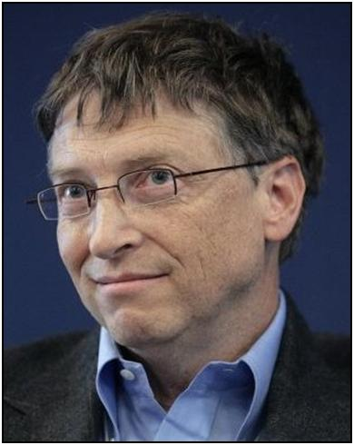
Bill Gates at the World Economic Forum , 26 January 2007

Copyright World Economic Forum (www.weforum.org), swiss-image.ch/Photo by Severin Nowacki - This file is licensed under the Creative Commons Attribution-Share Alike 2.0 Generic license.
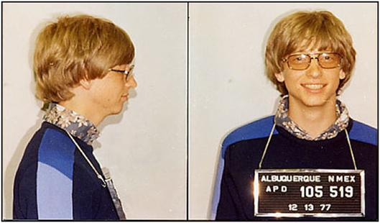
Bill Gates was photographed by the Albuquerque, New Mexico police in 1977 after a traffic violation (details of which have been lost over time)

Author: Albuquerque, New Mexico police department
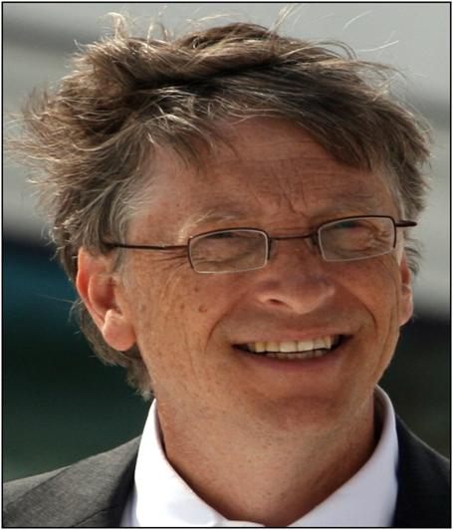
3 June 2009

Author: Kjetil Ree - This file is licensed under the Creative Commons Attribution-Share Alike 3.0 Unported license.
William Henry "Bill" Gates III (born October 28, 1955), is an American business magnate, investor, philanthropist, author, and former CEO and current chairman of Microsoft, the software company he founded with Paul Allen. He is consistently ranked among the world's wealthiest people, and was the wealthiest overall from 1995 to 2009, excluding 2008, when he was ranked third. During his career at Microsoft, Gates held the positions of CEO and chief software architect, and remains the largest individual shareholder, with more than 8 percent of the common stock. He has also authored or co-authored several books.
Gates is one of the best-known entrepreneurs of the personal computer revolution. Although he is admired by many, a number of industry insiders criticize his business tactics; which they consider anti-competitive, an opinion that has in some cases been upheld by the courts. In the later stages of his career, Gates has pursued a number of philanthropic endeavors, donating large amounts of money to various charitable organizations and scientific research programs through the Bill and Melinda Gates Foundation, established in 2000.
Gates stepped down as chief executive officer of Microsoft in January 2000; he remained as chairman and created the position of chief software architect. In June 2006, Gates announced that he would be transitioning from full-time work at Microsoft to part-time work, and full-time work at the Bill and Melinda Gates Foundation. He gradually transferred his duties to Ray Ozzie, chief software architect, and Craig Mundie, chief research and strategy officer. Gates' last full-time day at Microsoft was June 27, 2008. He remains at Microsoft as non-executive chairman.
Antitrust litigation:
Many decisions that led to antitrust litigation over Microsoft's business practices have had Gates' approval. In the 1998 United States v. Microsoft case, Gates gave deposition testimony that several journalists characterized as evasive . He argued with examiner David Boies over the contextual meaning of words like "compete", "concerned" and "we".
BusinessWeek reported: “Early rounds of his deposition show him offering obfuscatory answers and saying 'I don't recall,' so many times that even the presiding judge had to chuckle. Worse, many of the technology chief's denials and pleas of ignorance were directly refuted by prosecutors with snippets of e-mail that Gates both sent and received.”
Gates later said he had simply resisted attempts by Boies to mischaracterize his words and actions. As to his demeanor during the deposition, he said, "Did I fence with Boies? . . . I plead guilty. Whatever that penalty is should be levied against me: rudeness to Boies in the first degree.” Despite Gates's denials, the judge ruled that Microsoft had committed monopolization and tying, and blocking competition, both in violation of the Sherman Antitrust Act.

Paul Allen - A good Guy
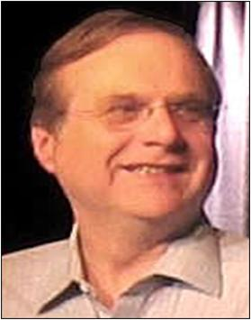
Paul Allen in 2005

This file is licensed under the Creative Commons Attribution-Share Alike 2.0 Generic license.
Paul Gardner Allen (born January 21, 1953) is an American business magnate, investor, real estate developer and philanthropist. Allen co-founded Microsoft with Bill Gates. He is also the 57th richest along with Viktor Vekselberg and Gerald Cavendish Grosvenor ( and family) who all rank the same with an estimated wealth of $13 billion as of 2011. He is the founder and chairman of Vulcan Inc., which manages his business and philanthropic efforts. Allen also has a multi-billion dollar investment portfolio which includes technology companies such as Evri and Gist, real estate holdings, and stakes in other technology, media, and content companies. Allen also owns two professional sports teams, the Seattle Seahawks of the National Football League (NFL), and the Portland Trail Blazers of the National Basketball Association (NBA). He is also part-owner of the Seattle Sounders FC, which joined Major League Soccer (MLS) in 2009. Allen's memoir Idea Man: A Memoir by the Cofounder of Microsoft was released on April 19, 2011.
Microsoft:
Allen co-founded Microsoft with Bill Gates in Albuquerque, New Mexico, in 1975, and began marketing a BASIC programming language interpreter. Allen came up with the original name of "Micro-Soft," as recounted in a 1995 Fortune magazine article. In 1980, after promising to deliver IBM a Disk Operating System (DOS) they had not yet developed for the Intel 8088-based IBM PC, Allen spearheaded a deal for Microsoft to purchase a Quick and Dirty Operating System (QDOS) written by Tim Paterson who, at the time, was employed at Seattle Computer Products. As a result of this transaction, Microsoft was able to secure a contract to supply the DOS that would eventually run on IBM's PC line. This contract with IBM was the watershed in Microsoft history that led to Allen and Gates's fabulous wealth.
Allen was diagnosed with Hodgkin's lymphoma in 1982. His cancer was successfully treated by several months of radiation therapy. However, he did not return to Microsoft and began distancing himself from the company. Allen officially resigned from his position on the Microsoft board in November 2000, but was asked to consult as a senior strategy advisor to the company's executives. He sold 68 million shares of Microsoft stock that year, but still owns a reported 138 million shares.

Steve Jobs - iCon-Man

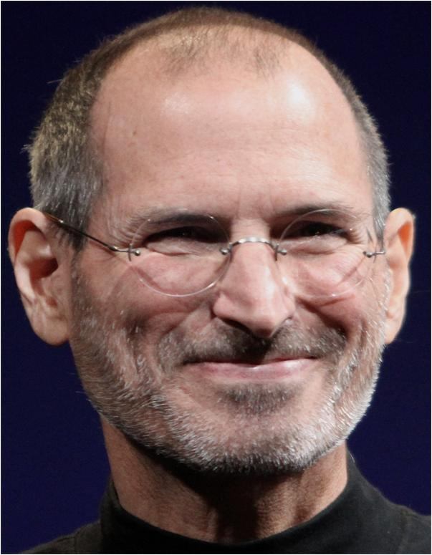

Credit: Matt Yohe - Wikipedia 2010
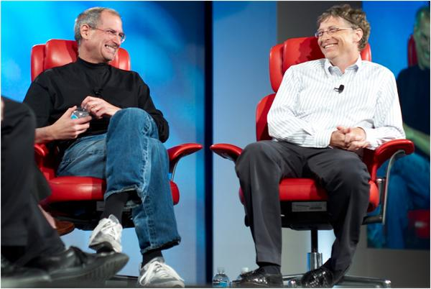
Walter Mossberg and Kara Swisher interview Steve Jobs and Bill Gates at 'D5: All Things Digital' conference in Carlsbad, California, in 2007

Joi Ito from Inbamura, Japan. This file is licensed under the Creative Commons Attribution 2.0 Generic license.
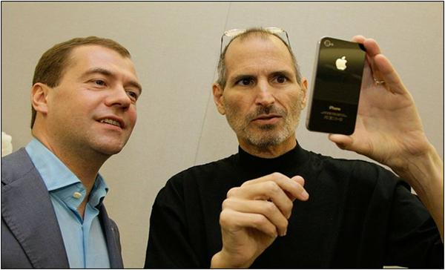
Jobs demonstrating the iPhone 4 to Russian President Dmitry Medvedev on 23 June 2010

This file comes from the website of the President of the Russian Federation and is copyrighted. This file is licensed under the Creative Commons Attribution 3.0 Unported Licence. In short: you are free to distribute and modify the file as long as you attribute www.kremlin.ru.
Steven Paul "Steve" Jobs (February 24, 1955 - October 5, 2011) was an American business magnate and inventor. He was co-founder, chairman, and chief executive officer of Apple Inc. Jobs was co-founder and previously served as chief executive of Pixar Animation Studios; he became a member of the board of directors of the Walt Disney Company in 2006, following the acquisition of Pixar by Disney.
In the late 1970s, Jobs - along with Apple co-founder Steve Wozniak, Mike Markkula and others - designed, developed, and marketed one of the first commercially successful lines of personal computers, the Apple II series. In the early 1980s, Jobs was among the first to see the commercial potential of Xerox PARC's mouse-driven graphical user interface, which led to the creation of the Apple Lisa and, one year later, the Macintosh. After losing a power struggle with the board of directors in 1985, Jobs left Apple and founded NeXT, a computer platform development company specializing in the higher-education and business markets.
In 1986, he acquired the computer graphics division of Lucasfilm Ltd, which was spun off as Pixar Animation Studios. He was credited in Toy Story (1995) as an executive producer. He remained CEO and majority shareholder at 50.1 percent until its acquisition by The Walt Disney Company in 2006, making Jobs Disney's largest individual shareholder at seven percent and a member of Disney's Board of Directors. Apple's 1996 buyout of NeXT brought Jobs back to the company he co-founded, and he served as its interim CEO from 1997, then becoming permanent CEO from 2000 onwards, spearheading the advent of the iPod, iPhone and iPad. From 2003, he fought a eight-year battle with cancer, and eventually resigned as CEO in August 2011, while on his third medical leave. He was then elected chairman of Apple's board of directors.
On October 5, 2011, around 3:00 p.m., Jobs died at his home in Palo Alto, California, aged 56, six weeks after resigning as CEO of Apple. A copy of his death certificate indicated respiratory arrest as the immediate cause of death, with "metastatic pancreas neuroendocrine tumor" as the underlying cause. His occupation was listed as "entrepreneur" in the "high tech" business.
Wealth:
Jobs earned only $1 a year as CEO of Apple, but held 5.426 million Apple shares, as well as 138 million shares in Disney (which he received in exchange for Disney's acquisition of Pixar). Jobs quipped that the $1 per annum he was paid by Apple was based on attending one meeting for 50 cents while the other 50 cents was based on his performance. Forbes estimated his net wealth at $8.3 billion in 2010, making him the 42nd wealthiest American.
Stock options backdating issue:
In 2001, Jobs was granted stock options in the amount of 7.5 million shares of Apple, with an exercise price of $18.30. It was alleged that the options had been backdated, and that the exercise price should have been $21.10. It was further alleged that Jobs had thereby incurred taxable income of $20,000,000 that he did not report, and that Apple overstated its earnings by that same amount. As a result, Jobs potentially faced a number of criminal charges and civil penalties. The case was the subject of active criminal and civil government investigations, though an independent internal Apple investigation completed on December 29, 2006, found that Jobs was unaware of these issues, and that the options granted to him were returned without being exercised in 2003.
On July 1, 2008, a $7 billion class action suit was filed against several members of the Apple Board of Directors for revenue lost due to the alleged securities fraud.
Management style:
Much was made of Jobs's aggressive and demanding personality. Fortune wrote that he was "considered one of Silicon Valley's leading egomaniacs.”
Cofounder Dan'l Lewin was quoted in Fortune as saying of that period, "The highs were unbelievable . . . But the lows were unimaginable", to which Jobs's office replied that his personality had changed since then.
In 2005, Jobs banned all books published by John Wiley and Sons from Apple Stores in response to their publishing an unauthorized biography, iCon: Steve Jobs. In its 2010 annual earnings report, Wiley said it had "closed a deal . . . to make its titles available for the iPad.". Jef Raskin, a former colleague, once said that Jobs "would have made an excellent king of France", alluding to Jobs's compelling and larger-than-life persona. Floyd Norman said that at Pixar, Jobs was a "mature, mellow individual" and never interfered with the creative process of the filmmakers.
Criticism:
Free software pioneer Richard Stallman dissented from the prevailing hagiographic views of Jobs in his blog, to draw attention to the legendary tight control that Apple exercised as corporate policy over their computers and handheld devices, restrictions over media and uses, and persistent violations of privacy: "Steve Jobs, the pioneer of the computer as a jail made cool, designed to sever fools from their freedom, has died".
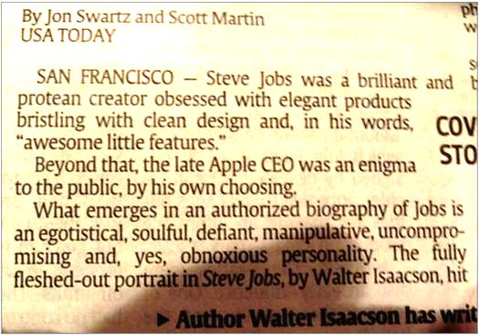
USA Article

Warren Buffett
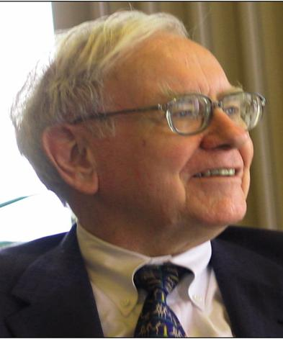
Warren Buffett speaking to a group of students from the Kansas University School of Business 6 May 2005

Work of Mark Hirschey - Permission for use of this work has been verified and archived in the Wikimedia OTRS system.
Warren Edward Buffett (born August 30, 1930) is an American business magnate, investor, and philanthropist. He is widely regarded as one of the most successful investors in the world. Often introduced as "Legendary investor, Warren Buffett", he is the primary shareholder, chairman and CEO of Berkshire Hathaway. He is consistently ranked among the world's wealthiest people. He was ranked as the world's wealthiest person in 2008, and is the third wealthiest person in the world as of 2011.
Buffett is called the "Wizard of Omaha", "Oracle of Omaha", or the "Sage of Omaha", and is noted for his adherence to the value investing philosophy and for his personal frugality despite his immense wealth. Buffett is also a notable philanthropist, having pledged to give away 99 percent of his fortune to philanthropic causes, primarily via the Gates Foundation. He also serves as a member of the board of trustees at Grinnell College.
Buffett was born in 1930 in Omaha, Nebraska, the second of three children and only son of U.S. Representative Howard Buffett, a fierce critic of the interventionist New Deal domestic and foreign policy.
Buffett became involved with Maurice R. Greenberg at AIG, with General Re providing reinsurance. On March 15, 2005, AIG's board forced Greenberg to resign from his post as Chairman and CEO under the shadow of criticism from Eliot Spitzer, former attorney general of the state of New York. On February 9, 2006, AIG and the New York State Attorney General's office agreed to a settlement in which AIG would pay a fine of $1.6 billion. In 2010, the federal government settled with Berkshire Hathaway for $92 million in return for the firm avoiding prosecution in an AIG fraud scheme, and undergoing 'corporate governance concessions'.
In 2002, Buffett entered in $11 billion worth of forward contracts to deliver U.S. dollars against other currencies. By April 2006, his total gain on these contracts was over $2 billion.
Buffett ran into criticism during the subprime crisis of 2007 - 2008, part of the late 2000s recession, that he had allocated capital too early resulting in suboptimal deals. “Buy American. I am.” he wrote for an opinion piece published recently in the New York Times. Buffett has called the 2007—present downturn in the financial sector "poetic justice". Buffett's Berkshire Hathaway suffered a 77% drop in earnings during Q3 2008 and several of his recent deals appear to be running into large mark-to-market losses.
Berkshire Hathaway acquired 10% perpetual preferred stock of Goldman Sachs. Some of Buffett's Index put options (European exercise at expiry only) that he wrote (sold) are currently running around $6.73 billion mark-to-market losses. The scale of the potential loss prompted the SEC to demand that Berkshire produce, "a more robust disclosure" of factors used to value the contracts. Buffett also helped Dow Chemical pay for its $18.8 billion takeover of Rohm and Haas. He thus became the single largest shareholder in the enlarged group with his Berkshire Hathaway, which provided $3 billion, underlining his instrumental role during the current crisis in debt and equity markets.
On March 18, 2011, Goldman Sachs acquired Federal Reserve approval to buy back Berkshire's preferred stock in Goldman. Buffet has been reluctant to give up the stock which averaged $1.4 million in dividends a day, stating: “I'm going to be the Osama bin Laden of capitalism; I'm on my way to an unknown destination in Asia where I'm going to look for a cave. If the U.S. Armed forces can't find Osama bin Laden in 10 years, let Goldman Sachs try to find me.”
. 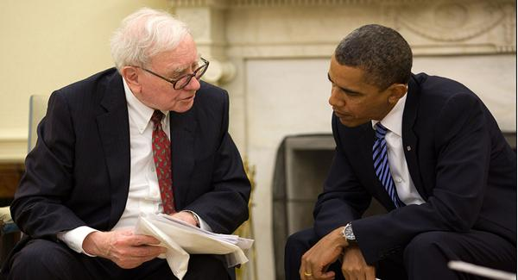
President Barack Obama and Warren Buffett in the Oval Office, July 14, 2010

This image is a work of an employee of the Executive Office of the President of the United States, taken or made during the course of the person's official duties. As a work of the U.S. federal government, the image is in the public domain. This photo has been digitally modified or digital data added according to Wikipedia.
Politics:
In addition to other political contributions over the years, Buffett has formally endorsed and made campaign contributions to Barack Obama's presidential campaign. On July 2, 2008, Buffett attended a $28,500 per plate fundraiser for Obama's campaign in Chicago hosted by Obama's National Finance Chair, Penny Pritzker and her husband, as well as Obama advisor Valerie Jarrett. Buffett backed Obama for president, and intimated that John McCain's views on social justice were so far from his own that McCain would need a "lobotomy" for Buffett to change his endorsement. During the second 2008 U.S. presidential debate, candidates John McCain and Barack Obama, after being asked first by presidential debate mediator Tom Brokaw, both mentioned Buffett as a possible future Secretary of the Treasury. Later, in the third and final presidential debate, Obama mentioned Buffett as a potential economic advisor. Buffett was also finance advisor to California Republican Governor Arnold Schwarzenegger during his 2003 election campaign
During the RJR Nabisco, Inc. hostile takeover fight in 1987, Buffett was quoted as telling John Gutfreund: “I’ll tell you why I like the cigarette business. It costs a penny to make. Sell it for a dollar. It’s addictive. And there’s fantastic brand loyalty.” Buffett, quoted in Barbarians at the Gate: The Fall of RJR Nabisco.
Dollar and gold:
The trade deficit induced Buffett to enter the foreign currency market for the first time in 2002. However, he substantially reduced his stake in 2005 as changing interest rates increased the costs of holding currency contracts. Buffett continues to be bearish on the dollar, and says he is looking to acquire companies which derive a substantial portion of their revenues from outside the United States. Buffett emphasized the non-productive aspect of a gold standard for the USD in 1998 at Harvard: “It gets dug out of the ground in Africa, or someplace. Then we melt it down, dig another hole, bury it again and pay people to stand around guarding it. It has no utility. Anyone watching from Mars would be scratching their head.”
Buffett stated that he only paid 19% of his income for 2006 ($48.1 million) in total federal taxes (due to their being from dividends and capital gains), while his employees paid 33% of theirs, despite making much less money. “How can this be fair?” Buffet asked, regarding how little he pays in taxes compared to his employees. “How can this be right?” He also added: “There’s class warfare, all right, but it’s my class, the rich class, that’s making war, and we’re winning.”

Tammy Faye (Bakker) Messner - Religion Scammer
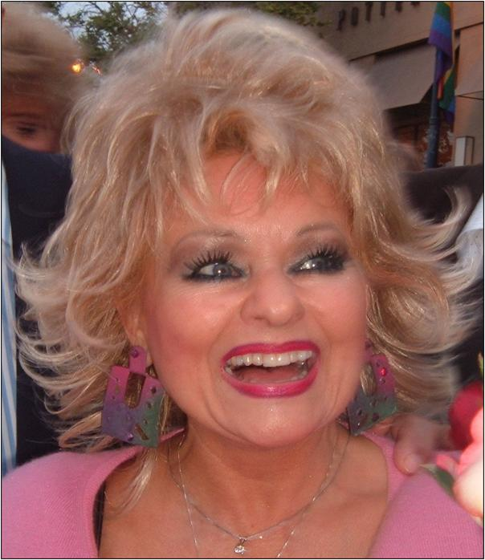
Tammy Faye Messner Date 14 April 2004

Source “The higher the hair, the closer to the lord” Author Darwin Bell This file is licensed under the Creative Commons Attribution 2.0 Generic license.
Tamara Faye LaValley Bakker Messner (March 7, 1942 - July 20, 2007) was an American Christian singer, evangelist, entrepreneur, author, talk show host, and television personality. She was married to televangelist, and later convicted felon, Jim Bakker (1961 - 92). She co-hosted with him on The PTL Club (1976 - 87). She was a participant in the 2004 season of the reality show The Surreal Life.
PTL collapse:
The Bakkers' control of PTL collapsed in 1987 after revelations that $287,000 had been paid from the organization to buy the silence of Jessica Hahn, who claims a forced sexual encounter with Jim Bakker.
The revelations invited scrutiny of the Bakkers, and charges made about their opulent lifestyle, including media reports of an air-conditioned doghouse at their Tega Cay, South Carolina, lakefront parsonage as well as gold-plated bathroom fixtures, dominated newscasts in the 1980s. The Bakkers' home, owned by the ministry, was actually an older home built in the early 1970s, and it was a few miles away from Heritage USA. Jim Bakker stated that the much-talked-about dog house was heated with an old heater to keep the dogs warm in the winter and the reported gold-plated fixtures were actually brass. The home was later sold by the ministry and burned to the ground not long thereafter. Jim Bakker wrote in his book I Was Wrong, that he watched the home burn on live television while incarcerated.
Her second husband was jailed and she was first diagnosed with colon cancer, she re-entered the public eye in a series of books, movies, and television appearances.

Jerry Falwell - Religion Scammer and Right-Wing Super-Screwball
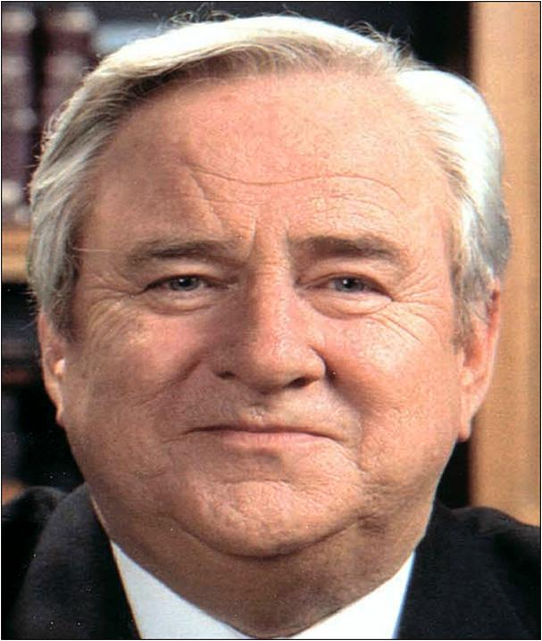
Dr. Jerry Falwell (2007), the founder of Liberty University, was a Christian pastor and televangelist

OTRS Wikimedia The permission for use of this work has been verified and archived in the Wikimedia OTRS system.
Jerry Lamon Falwell, Sr. (August 11, 1933 - May 15, 2007) was an evangelical fundamentalist Southern Baptist pastor, televangelist, and a conservative commentator from the United States. He was the founding pastor of the Thomas Road Baptist Church, a megachurch in Lynchburg, Virginia. He founded Lynchburg Christian Academy (now Liberty Christian Academy) in 1967, Liberty University in 1971, and cofounded the Moral Majority in 1979.
In 1956, at age 22, Falwell founded the Thomas Road Baptist Church of Lynchburg, (TRBC) where he served as pastor. The Church went on to become a megachurch, and is now run by Jerry Falwell's son Jonathan Falwell, who serves in the same capacity as his father.
Moral Majority:
In 1979, Falwell founded the Moral Majority, which became one of the largest political lobby groups for evangelical Christians in the United States during the 1980s. The Moral Majority was founded as being "pro-family", "pro-life", "pro-defense" and pro-Israel. The group is credited with delivering two thirds of the white, evangelical Christian vote to Ronald Reagan during the 1980 presidential election. During his time as head of the Moral Majority, Falwell consistently pushed for Republican candidates and for conservative politics. This led Billy Graham, and other conservative Christian leaders, to criticize him for sermons about political issues that lacked a moral element. (Note: it is illegal to mention politics and retain the tax exempt status; I guess he is an exception to the rule for being a good Republican. PWW)
Civil rights:
On his evangelist program The Old-Time Gospel Hour in the mid 1960s, Falwell regularly featured segregationist politicians like Lester Maddox and George Wallace. About Martin Luther King he said: "I do question the sincerity and nonviolent intentions of some civil rights leaders such as Dr. Martin Luther King, Jr., Mr. James Farmer, and others, who are known to have left wing associations."
In speaking of the Brown vs. Board of Education ruling, he said, in 1958:
"If Chief Justice Warren and his associates had known God's word and had desired to do the Lord's will, I am quite confident that the 1954 decision would never had been made. The facilities should be separate. When God has drawn a line of distinction, we should not attempt to cross that line."
In 1977, Falwell supported Anita Bryant's campaign, which was called by its proponents "Save Our Children", to overturn an ordinance in Dade County, Florida prohibiting discrimination on the basis of sexual orientation, and he supported a similar movement in California.
“Jews can make more money accidentally than you can on purpose”, was another of his famious lines.
Falwell condemned homosexuality as forbidden by the Bible. Pro-gay rights groups called Falwell an "Agent of intolerance" and "The founder of the anti-gay industry" for statements he has made and for campaigning against LGBT social movements. Falwell told one crowd, "Gay folks would just as soon kill you as look at you."
Falwell also regularly linked the AIDS pandemic to LGBT issues and stated, "AIDS is not just God's punishment for homosexuals, it is God's punishment for the society that tolerates homosexuals.” Amongst many remarks over the years he is probably most known for statements attributed to him about a Teletubby being a homosexual role model for homosexual recruitment and stating that LGBT organizations angered God, thereby in part causing God to let the September 11 attacks and Hurricane Katrina happen.
Labor unions:
Falwell has also said, "Labor unions should study and read the Bible instead of asking for more money. When people get right with God, they are better workers."
SEC and bonds:
In 1972, the U.S. Securities and Exchange Commission (SEC) launched an investigation of bonds issued by Falwell's organizations. The SEC charged Falwell's church with "fraud and deceit" in the issuance of $6.5 million in unsecured church bonds. The church won a 1973 federal court case prosecuted at the behest of the SEC, in which the Court exonerated the church and ruled that while technical violations of law did occur, there was no proof the Church intended any wrong-doing.
Falwell versus Penthouse:
Falwell filed a $10 million lawsuit against Penthouse for publishing an article based upon interviews he gave to freelance reporters, after failing to convince a federal court to place an injunction upon the publication of that article. The suit was dismissed in Federal district court on the grounds that the article was not defamatory or an invasion of Falwell's privacy (the Virginia courts had not recognized this privacy tort, which is recognized in other states).
Falwell versus Hustler:
In November 1983, Larry Flynt's pornographic magazine, Hustler, carried a parody advertisement of a Campari ad, featuring a fake interview with Falwell in which he admits that his "first time" was incest with his mother in an outhouse while drunk. Falwell sued for $45 million in compensation alleging invasion of privacy, libel, and intentional infliction of emotional distress. A jury rejected the invasion of privacy and libel claims, holding that the parody could not have reasonably been taken to describe true events, but ruled in favor of Falwell on the emotional distress claim. This was upheld on appeal. Flynt then appealed to the Supreme Court, winning a unanimous decision on February 24, 1988. The ruling held that public figures cannot circumvent First Amendment protections by attempting to recover damages based on emotional distress suffered from parodies. The decision in favor of Flynt strengthened free speech rights in the United States in relation to parodies of public figures.
After the death of Falwell, Larry Flynt released a comment regarding his friendship over the years with Falwell. "My mother always told me that no matter how much you dislike a person, when you meet them face to face you will find characteristics about them that you like. Jerry Falwell was a perfect example of that. I hated everything he stood for, but after meeting him in person, years after the trial, Jerry Falwell and I became good friends. He would visit me in California and we would debate together on college campuses. I always appreciated his sincerity even though I knew what he was selling and he knew what I was selling."

Pat Robertson - Religion Scammer and Right Wing Screwball

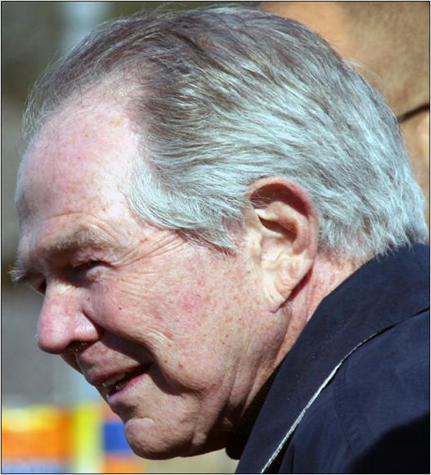
12 February 2006

OTRS Wikimedia The permission for use of this work has been verified and archived in the Wikimedia OTRS system.
Marion Gordon "Pat" Robertson (born March 22, 1930) is a media mogul, television evangelist, (Politician), ex-Baptist minister and businessman who is politically aligned with the Christian Right in the United States.
He is the founder of numerous organizations and corporations, including the American Center for Law and Justice (ACLJ), the Christian Broadcasting Network (CBN), the Christian Coalition, Flying Hospital, International Family Entertainment Inc., Operation Blessing International Relief and Development Corporation, CBN Asia and Regent University. He is the host of The 700 Club, a Christian TV program airing on channels throughout the United States and on CBN network affiliates worldwide.
The son of U.S. Senator A. Willis Robertson, Robertson is a Southern Baptist and was active as an ordained minister with that denomination for many years, but holds to a charismatic theology not traditionally common among Southern Baptists. He unsuccessfully campaigned to become the Republican Party's nominee in the 1988 presidential election. As a result of his seeking political office, he no longer serves in an official role for any church. His media and financial resources make him a recognized, influential, and controversial public voice for conservative Christianity in the United States.
1988 presidential bid:
In September 1986, Robertson announced his intention to seek the Republican nomination for President of the United States. Robertson said he would pursue the nomination only if three million people signed up to volunteer for his campaign by September 1987. Three million responded, and by the time Robertson announced he would be running in September 1987, he also had raised millions of dollars for his campaign fund. He surrendered his ministerial credentials and turned leadership of CBN over to his son, Tim. His campaign, however, against incumbent Vice President George H. W. Bush, was seen as a long shot.
Robertson ran on a standard conservative platform. Among his policies, he wanted to ban pornography, reform the education system, and eliminate departments such as the Department of Education and the Department of Energy. He also supported a constitutional amendment requiring a balanced federal budget.
Robertson's campaign got off to a strong second-place finish in the Iowa caucus, ahead of Bush. He did poorly in the subsequent New Hampshire primary, however, and was unable to be competitive once the multiple-state primaries began. Robertson ended his campaign before the primaries were finished. His best finish was in Washington, winning the majority of caucus delegates. He later spoke at the 1988 Republican National Convention in New Orleans and told his remaining supporters to cast their votes for Bush, who ended up winning the nomination and the election. He then returned to CBN and has remained there as a religious broadcasting broadcaster.
Robertson's extensive business interests have earned him a net worth estimated between $200 million and $1 billion
A fan of Thoroughbred horse racing, Robertson paid $520,000 for a colt he named Mr. Pat. Trained by John Kimmel, Mr. Pat was not a successful runner. He was nominated for, but did not run in, the 2000 Kentucky Derby.
According to a June 2, 1999, article in The Virginian-Pilot, Robertson had extensive business dealings with Liberian president Charles Taylor. According to the article, Taylor gave Robertson the rights to mine for diamonds in Liberia's mineral-rich countryside. According to two Operation Blessing pilots who reported this incident to the state of Virginia for investigation in 1994, Robertson used his Operation Blessing planes to haul diamond-mining equipment to Robertson's mines in Liberia, despite the fact that Robertson was telling his 700 Club viewers that the planes were sending relief supplies to the victims of the genocide in Rwanda. In response to Taylor's alleged crimes against humanity, the United States Congress passed a bill In November 2003 that offered two million dollars for his capture. Robertson accused President George W. Bush of "undermining a Christian, Baptist president to bring in Muslim rebels to take over the country.” At the time, Taylor was harboring Al Qaeda operatives who were funding their operations through the illegal diamond trade. On February 4, 2010, at his war crimes trial in the Hague, Taylor testified that Robertson was his main political ally in the U.S., and that he had volunteered to make Liberia's case before U.S. administration officials in exchange for concessions to Robertson's Freedom Gold, Ltd., to which Taylor gave a contract to mine gold in southeast Liberia. In 2010, a spokesman for Robertson said that the company's arrangements — in which the Liberian government got a 10 percent equity interest in the company and Liberians could purchase at least 15 percent of the shares after the exploration period — were similar to many American companies doing business in Africa at the time.
Political activism:
After his unsuccessful presidential campaign, Robertson started the Christian Coalition, a 1.7 million member Christian right organization that campaigned mostly for conservative candidates. It was sued by the Federal Election Commission "for coordinating its activities with Republican candidates for office in 1990, 1992 and 1994 and failing to report its expenditures".
In 1994, the Coalition was fined for "improperly [aiding] then Representative Newt Gingrich (R-GA) and Oliver North, who was then the Republican Senate nominee in Virginia." Robertson left the Coalition in 2001.
On November 7, 2007, Robertson announced that he was endorsing Rudy Giuliani to be the Republican nominee in the 2008 Presidential election.
While usually associated with the political right, Pat Robertson has recently begun endorsing environmental causes. He appears in a commercial with Al Sharpton, joking about this, and urging people to join the We can Solve it Campaign against global warming.
In January 2009, on a broadcast of The 700 Club, Robertson stated that he is "adamantly opposed" to the division of Jerusalem between Israel and the Palestinians. He also stated that Armageddon is "not going to be fought at Megiddo" but will be the "battle of Jerusalem," when "the forces of all nations come together and try to take Jerusalem away from the Jews. Jews are not going to give up Jerusalem — they shouldn't — and the rest of the world is going to insist they give it up." Robertson added that Jerusalem is a "spiritual symbol that must not be given away" because "Jesus Christ the Messiah will come down to the part of Jerusalem that the Arabs want," and that's "not good."
Controversies and criticisms:
Controversies surrounding Robertson include his earlier work as a faith healer, his claim that some Protestant denominations harbor the spirit of the Antichrist, and his claims of having the power to deflect hurricanes through prayer; he has also denounced Hinduism as "demonic", and Islam as "Satanic.” Robertson has issued multiple condemnations of feminism, homosexuality, abortion, and liberal college professors. Robertson also had financial ties to former presidents Charles Taylor of Liberia and Mobutu Sese Seko of Zaire, both internationally denounced for their human rights violations. Robertson was criticized worldwide, for his call for Hugo Chavez’s assassination, and for his remarks concerning Ariel Sharon's health, as an act of God.
The week of September 11, 2001, Robertson discussed the terror attacks with Jerry Falwell, who said that "the ACLU has to take a lot of blame for this" in addition to "the pagans, and the abortionists, and the feminists, and the gays, and the lesbians [who have] helped [the terror attacks of September 11th] happen.” Robertson replied, "I totally concur." Both evangelists came under attack from President George W. Bush for their statements, for which Falwell later issued an apology.
Less than two weeks after Hurricane Katrina killed 1,836 people, Robertson implied on the September 12th broadcast of The 700 Club that the storm was God's punishment in response to America's abortion policy. He suggested that September 11 and the disaster in New Orleans "could. . . be connected in some way".
On November 9, 2009, Robertson said that Islam is "a violent political system bent on the overthrow of the governments of the world and world domination." He went on to elaborate that "you're dealing with not a religion, you're dealing with a political system, and I think we should treat it as such, and treat its adherents as such as we would members of the communist party, members of some fascist group."
Robertson's response to the 2010 Haiti earthquake also drew controversy and condemnation. Robertson claimed that Haiti's founders had sworn a "Pact to the Devil" in order to liberate themselves from the French slave owners and indirectly attributed the earthquake to the consequences of the Haitian people being "Cursed" for doing so. CBN later issued a statement saying that Robertson's comments "were based on the widely-discussed 1791 slave rebellion led by Dutty Boukman at Bois Caiman, where the slaves allegedly made a famous pact with the devil in exchange for victory over the French." Various prominent voices of mainline and evangelical Christianity promptly denounced Robertson's remarks as false, untimely, insensitive, and not representative of Christian thought on the issue.
Predictions:
Several times near New Year, Robertson has announced that God told him several truths or events that would happen in the following year. "I have a relatively good track record," he said. "Sometimes I miss."
1982: Doomsday: In late 1976, Robertson predicted that the end of the world was coming in October or November 1982. In a May 1980 broadcast of The 700 Club he stated, "I guarantee you by the end of 1982 there is going to be a judgment on the world."
In September 2011, Robertson and several others who incorrectly predicted various dates for the end of world were jointly awarded an Ig Nobel Prize for "Teaching the world to be careful when making mathematical assumptions and calculations".
2006: Pacific Northwestern tsunami: In May 2006, Robertson declared that storms and possibly a tsunami would hit America's coastline sometime in 2006. Robertson supposedly received this revelation from God during an annual personal prayer retreat in January. The claim was repeated four times on The 700 Club.
On May 8, 2006, Robertson said, "If I heard the Lord right about 2006, the coasts of America will be lashed by storms.” On May 17, 2006, he elaborated, "There well may be something as bad as a tsunami in the Pacific Northwest.” While this claim didn't garner the same level of controversy as some of his other statements, it was generally received with mild amusement by the Pacific Northwest media. The History Channel's initial airing of its new series, Mega Disasters, debut episode "West Coast Tsunami", was broadcast the first week of May.
2007: Terror attack: On the January 2, 2007, broadcast of The 700 Club, Robertson said that God spoke to him and told him that "Mass killings" were to come during 2007, due to a terrorist attack on the United States. He added, "The Lord didn't say nuclear. But I do believe it will be something like that.” When a terrorist attack failed to happen in 2007, Robertson said, in January 2008, "All I can think is that somehow the people of God prayed and God in his mercy spared us."
2008: Worldwide violence and American recession: On the January 2, 2008 episode of The 700 Club, Pat Robertson predicted that 2008 would be a year of worldwide violence. He also predicted that a recession would occur in the United States that would be followed by a stock market crash by 2010. However, there was a decrease in overall deaths for the period, and the American economy had already entered a recession in 2007, with increased household debt and the collapse of financial institutions.
2008: Mideast meltdown: In October 2008, Robertson posted a press release on the Georgian Conflict speculating that the conflict is a Russian ploy to enter the Middle East, and that instability caused by a predicted pre-emptive strike by Israel on Iran would result in Syria's and Iran's launching nuclear strikes on other targets. He also said that if the United States were to oppose Russia's expansion, nuclear strikes on American soil are also pending. "We will suffer grave economic damage, but will not engage in military action to stop the conflict. However, we may not be spared nuclear strikes against coastal cities. In conclusion, it is my opinion that we have between 75 and 120 days before the Middle East starts spinning out of control."
2009: Economic chaos and recovery: On the January 1, 2009 broadcast of The 700 Club, Robertson said, "If I'm hearing [God] right, gold will go to about $1900 an ounce and oil to $300 a barrel." He also suggested that Americans would broadly accept socialism. Despite these predictions, he also said that economically, "things are getting ready to turn around."
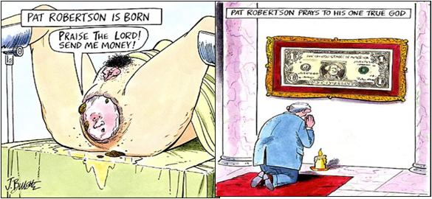
Hustler Magazine jokes about Pat Robertson

If there are problems with Hustler’s okay, these will need to be pulled

Crystal Cathedral - Robert H. Schuller Religion Scammers
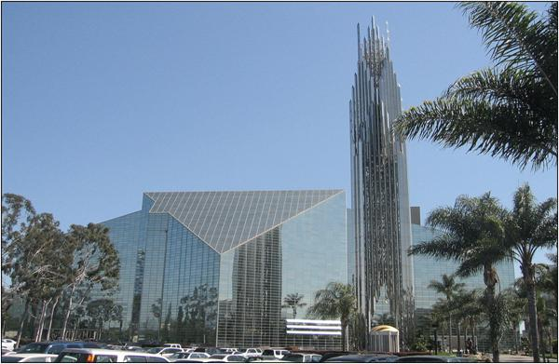
The exteriors of Crystal Cathedral, Garden Grove, CA, USA. 8 May 2007

Arnold C (Buchanan-Hermit) The copyright holder of this file allows anyone to use it for any purpose, provided that the copyright holder is properly attributed. Redistribution, derivative work, commercial use, and all other use is permitted.
The Crystal Cathedral is a Protestant Christian church in the city of Garden Grove, in Orange County, California, United States founded by Robert H. Schuller. The prominent architect Philip Johnson designed the main sanctuary building which seats 2,736. It was constructed using over 10,000 rectangular panes of glass.
The name "Crystal Cathedral" is merely an alliterative colloquialism and does not mean that the church is a cathedral in the sense of being a church where there is a bishop's official seat; the Reformed Church in America is governed by elders. Nor is the church made of crystal. Nevertheless, it is a Southern California architectural landmark.
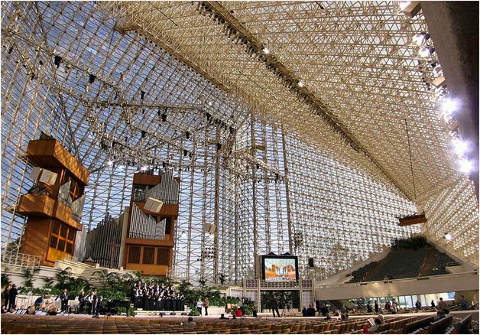
The Interior of the Crystal Cathedral, with the "Glory of Easter" set installed

This file is licensed under the Creative Commons Attribution-Share Alike 3.0 Unported license.
On October 18, 2010, the board of the Crystal Cathedral filed for bankruptcy in Santa Ana, California. Beginning in 2010, creditors filed lawsuits to collect money due to them for providing goods, services and broadcasting The Hour of Power weekly TV show. A board member said that the total debt was $55 million. The church's board filed for bankruptcy on October 18, 2010, citing $43 million in debt including a $36 million mortgage and $7.5 million in other debt. Church officials said that they had been trying to negotiate payments but after several suits were filed and writs of attachment were granted the church had to declare bankruptcy. The church has received offers for the building from a real estate investment group and from Chapman University, both with the provision of being leased back to the church.
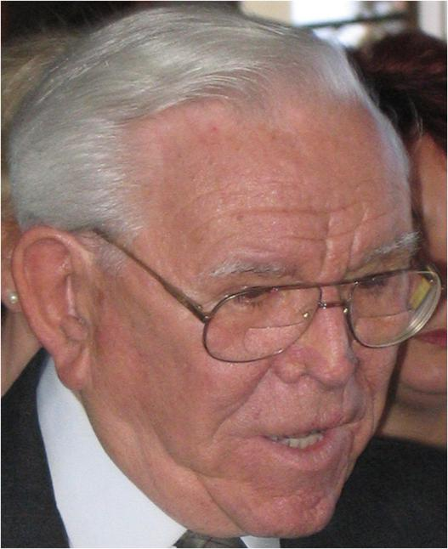
Robert H. Schuller

This file is licensed under the Creative Commons Attribution 3.0 Unported license.
On July 3, 2011, local newspapers and other outlets reported that Robert H. Schuller had been voted off the church's board of trustees by the other board members.
On July 7, 2011, the Roman Catholic Diocese of Orange announced that it was "potentially interested in buying" the building "To meet the needs of the 1.2 million Catholics in Orange County". Two weeks later, the diocese followed up with a cash offer of $53.6 million which included a lease-back provision at below market rates for a period of time. (This deal proceeded successfully.)
The Crystal Cathedral broadcasts its church services around the world on a television show called The Hour of Power, said to be the most-watched Christian program worldwide, with an estimated average of 20 million viewers tuning in each week
(20 million viewers and they can’t get enough out of the fools to pay their bills? Where did the money go?
Many years ago, a friend of mine put in a surveillance TV system to watch the eight full time money counters; Schuller did not trust his Christians not to steal some of the money. PWW)

Jimmy Swaggart - Religion Scammer
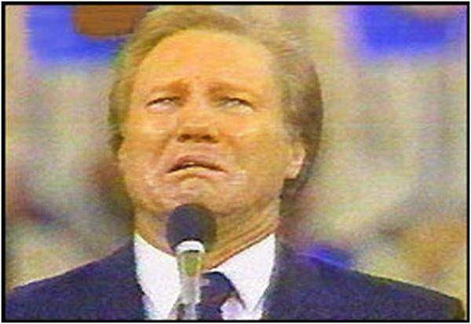
Swaggart confession screenshot
Jimmy Lee Swaggart (born March 15, 1935) is a Pentecostal American pastor, teacher, musician, television host, and televangelist. He has preached to crowds around the world through his weekly telecast. According to the official website for Jimmy Swaggart Ministries, his 1980s telecast was transmitted to over 3,000 stations and cable systems each week.
In February 1988, Swaggart stirred controversy after a private investigation found he had solicited a prostitute. Initially, Swaggart denied the accusations; but, as a media investigation proceeded, he acknowledged that some allegations were true. He later apologized for the acts in a televised broadcast.
1991 scandal:
On October 11, 1991, Swaggart was found, for the second time, in the company of a prostitute, Rosemary Garcia, when he was pulled over by the California Highway Patrol in Indio, California, for driving on the wrong side of the road. According to Garcia, Swaggart stopped to proposition her on the side of the road. When the patrolman asked Garcia why she was with Swaggart, she replied, "He asked me for sex. I mean, that's why he stopped me. That's what I do. I'm a prostitute." Rather than confessing to his congregation, Swaggart told those at Family Worship Center that "The Lord told me it's flat none of your business." Swaggart's son then announced to the stunned audience that his father would be temporarily stepping down as head of Jimmy Swaggart Ministries for "A time of healing and counseling."

Bernard Madoff - Biggest Scammer Ever
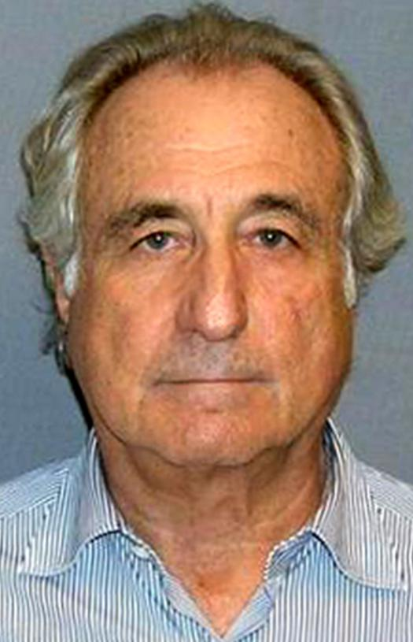
Bernard Madoff's mugshot

This image is a work of a United States Department of Justice employee, taken or made during the course of an employee's official duties. As a work of the U.S. federal government, the image is in the public domain (17 U.S.C. § 101 and 105).
Bernard Lawrence "Bernie" Madoff born April 29, 1938) is a former American stockbroker, entrepreneur, and investor. He is the former non-executive chairman of the NASDAQ stock market, and the admitted operator of a Ponzi scheme that is considered to be the largest financial fraud in U.S. history.
In March 2009, Madoff pleaded guilty to 11 federal felonies and admitted to turning his wealth management business into a massive Ponzi scheme that defrauded thousands of investors of billions of dollars. Madoff said he began the Ponzi scheme in the early 1990s. However, federal investigators believe the fraud began as early as the 1970s, and those charged with recovering the missing money believe the investment operation may never have been legitimate. The amount missing from client accounts, including fabricated gains, was almost $65 billion. The court-appointed trustee estimated actual losses to investors of $18 billion. On June 29, 2009, he was sentenced to 150 years in prison, the maximum allowed.
Jeffry Picower, rather than Madoff, appears to have been the largest beneficiary of Madoff's Ponzi scheme, and his estate settled the claims against it for $7.2 billion. J.P. Morgan Chase and Co. may have also benefitted from the scheme - through interest and fees charged - to the tune of $1 billion. Trustee Irving Picard has filed suit seeking the return of $1 billion and damages of $5.4 billion. Morgan denied complicity. According to the same lawsuit, New York Mets owners Fred Wilpon and Saul Katz and associated individuals and firms, received $300 million from the scheme. Wilpon and Katz "categorically reject" the charges.
Madoff founded the Wall Street firm Bernard L. Madoff Investment Securities LLC in 1960, and was its chairman until his arrest on December 11, 2008. The firm was one of the top market maker businesses on Wall Street, which bypassed "specialist" firms by directly executing orders over the counter from retail brokers.
On December 10, 2008, Madoff's sons told authorities that their father had confessed to them that the asset management unit of his firm was a massive Ponzi scheme, and quoted him as describing it as "one big lie." The following day, FBI agents arrested Madoff and charged him with one count of securities fraud. The U.S. Securities and Exchange Commission (SEC) had previously conducted investigations into Madoff's business practices, but did not uncover the massive fraud.
Early life:
Madoff was born on April 29, 1938 in Queens, New York City, New York. He is the son of Jewish parents Sylvia (nee Muntner) (December 1911 - December 1974), a homemaker, and Ralph Madoff (June 1910 - July 1972), a plumber and stockbroker. Madoff's grandparents were Jewish emigrants from Poland, Romania and Austria. He is the second of three children; his siblings are Sondra (Weiner) and Peter. Madoff graduated from Far Rockaway High School in 1956. He attended the University of Alabama for one year, where he became a brother of the Tau Chapter of the Sigma Alpha Mu fraternity, then transferred to and graduated from Hofstra University in 1960 with a Bachelor of Arts in political science. Madoff briefly attended Brooklyn Law School, but founded the Wall Street firm Bernard L. Madoff Investment Securities LLC and remained working for his own company.
Career:
Madoff was chairman of Bernard L. Madoff Investment Securities LLC from its startup in 1960 until his arrest on December 11, 2008.
The firm started as a penny stock trader with $5,000 ($37,000 today) that Madoff earned from working as a lifeguard and sprinkler installer. He further secured a loan of $50,000 from his father-in-law which he also used to set up Bernard L. Madoff Investment Securities LLC. His business grew with the assistance of his father-in-law, accountant Saul Alpern, who referred a circle of friends and their families. Initially, the firm made markets (quoted bid and ask prices) via the National Quotation Bureau's Pink Sheets. In order to compete with firms that were members of the New York Stock Exchange trading on the stock exchange's floor, his firm began using innovative computer information technology to disseminate its quotes. After a trial run, the technology that the firm helped develop became the NASDAQ.
The firm functioned as a third-market provider, which bypassed exchange specialist firms, by directly executing orders over the counter from retail brokers. At one point, Madoff Securities was the largest market maker at the NASDAQ and in 2008 was the sixth largest market maker on Wall Street. The firm also had an investment management and advisory division, which it did not publicize, that was the focus of the fraud investigation.
Madoff was "the first prominent practitioner" of payment for order flow, in which a dealer pays a broker for the right to execute a customer's order. This has been called a "legal kickback." Some academics have questioned the ethics of these payments. Madoff has argued that these payments did not alter the price that the customer received. He viewed the payments as a normal business practice: "If your girlfriend goes to buy stockings at a supermarket, the racks that display those stockings are usually paid for by the company that manufactured the stockings. Order flow is an issue that attracted a lot of attention but is grossly overrated."
Madoff was active in the National Association of Securities Dealers (NASD), a self-regulatory securities industry organization and has served as the Chairman of the Board of Directors and on the Board of Governors of the NASD.
Government access:
Since 1991, Madoff and his wife have contributed about $240,000 to federal candidates, parties and committees, including $25,000 a year from 2005 through 2008 to the Democratic Senatorial Campaign Committee. The Committee has returned $100,000 of the Madoffs' contributions to Irving Picard, the bankruptcy trustee who oversees all claims. Senator Charles E. Schumer returned almost $30,000 received from Madoff and his relatives to the trustee, and Senator Christopher J. Dodd donated $1,500 to the Elie Wiesel Foundation for Humanity, a Madoff victim.
The Madoff family gained access to Washington's lawmakers and regulators through the industry's top trade group. The Madoff family has long-standing, high-level ties to the Securities Industry and Financial Markets Association (SIFMA), the primary securities industry organization. Bernard Madoff sat on the Board of Directors of the Securities Industry Association, which merged with the Bond Market Association in 2006 to form SIFMA.
Madoff's brother Peter then served two terms as a member of SIFMA's Board of Directors. He stepped down from the Board of Directors of SIFMA in December 2008, as news of the Ponzi scheme broke. From 2000 to 2008 the two Madoff brothers gave $56,000 to SIFMA, and tens of thousands of dollars more to sponsor SIFMA industry meetings. Bernard Madoff's niece Shana Madoff was active on the Executive Committee of SIFMA's Compliance and Legal Division, but resigned her SIFMA position shortly after her uncle's arrest.
In 2004 Genevievette Walker-Lightfoot, a lawyer in the SEC's Office of Compliance Inspections and Examinations, informed her supervisor branch chief Mark Donohue that her review of Madoff found numerous inconsistencies and recommended further questioning. However, because of agency pressure to investigate the mutual fund industry, she had to conclude work on the probe. Donohue's boss, Eric Swanson, an assistant director of the department, married Shana Madoff, after the investigation concluded in 2005. A spokesman for Swanson, who has left the SEC, said he "did not participate in any inquiry of Bernard Madoff Securities or its affiliates while involved in a relationship" with Shana Madoff.
While awaiting sentencing, Madoff met with the SEC's Inspector General, H. David Kotz, who is conducting an investigation into how regulators failed to detect the fraud despite numerous red flags. Madoff said he could have been caught in 2003, but bumbling investigators acted like "Lt. Colombo" and never asked the right questions.
"I was astonished. They never even looked at my stock records. If investigators had checked with the Depository Trust Company, a central securities depository, it would've been easy for them to see. If you're looking at a Ponzi scheme, it's the first thing you do." Madoff said in the June 17, 2009, interview that SEC Chairman Mary Schapiro was a "dear friend," and SEC Commissioner Elisse Walter was a "terrific lady" whom he knew "pretty well."
Since Madoff's arrest, the SEC has been criticized for its lack of financial expertise and lack of due diligence, despite having received complaints from Harry Markopolos and others for almost a decade. The SEC's Inspector General, H. David Kotz, found that since 1992, there were six botched investigations of Madoff by the SEC, either through incompetent staff work or neglecting allegations of financial experts and whistle-blowers. At least some of the SEC investigators doubted whether Madoff was even trading.
Investment scandal:
Concerns about Madoff's business surfaced as early as 1999, when financial analyst Harry Markopolos informed the U.S. Securities and Exchange Commission (SEC) that he believed it was legally and mathematically impossible to achieve the gains Madoff claimed to deliver. According to Markopolos, he knew within five minutes that Madoff's numbers didn't add up, and it took four hours of failed attempts to replicate them to conclude Madoff was a fraud. He was ignored by the Boston SEC in 2000 and 2001, as well as by Meaghan Cheung at the New York SEC in 2005 and 2007 when he presented further evidence. He has since published a book, No One Would Listen, about the frustrating efforts he and his team made over a ten-year period to alert the government, the industry, and the press about the Madoff fraud.
Although Madoff's wealth management business ultimately grew into a multi-billion-dollar operation, none of the major derivatives firms traded with him because they didn't think his numbers were real. None of the major Wall Street firms invested with him either, and several high-ranking executives at those firms suspected he wasn't legitimate.
Others also contended it was inconceivable that the growing volume of Madoff accounts could be competently and legitimately serviced by his documented accounting/auditing firm, a three-person firm with only one active accountant.
The Federal Bureau of Investigation complaint says that during the first week of December 2008, Madoff confided to a senior employee, identified by Bloomberg News as one of his sons, that he said he was struggling to meet $7 billion in redemptions. According to the sons, Madoff told Mark Madoff on December 9 that he planned to pay out $173 million in bonuses two months early. Madoff said that "he had recently made profits through business operations, and that now was a good time to distribute it." Mark told Andrew Madoff, and the next morning they went to their father's apartment and asked him how he could pay bonuses to his staff if he was having trouble paying clients. With Ruth Madoff nearby, Madoff told them he was "finished," that he had "absolutely nothing" left, that his investment fund was "just one big lie" and "basically, a giant Ponzi scheme." According to their attorney, Madoff's sons then reported their father to federal authorities. On December 11, 2008, he was arrested and charged with securities fraud.
Madoff posted $10 million bail in December 2008 and remained under 24-hour monitoring and house arrest in his Upper East Side penthouse apartment until March 12, 2009, when Judge Denny Chin revoked his bail and remanded him to the Metropolitan Correctional Center. Chin claimed Madoff was a flight risk, because of his age, wealth, and the prospect of spending the rest of his life in prison. Prosecutors filed two asset forfeiture pleadings which include lists of valuable real and personal property as well as financial interests and entities.
Madoff's lawyer, Ira Sorkin, filed an appeal, and prosecutors responded with a notice of opposition. On March 20, 2009, an appellate court denied Madoff's request to be released from jail and returned to home confinement until his June 29, 2009, sentencing. On June 22, 2009, Sorkin hand-delivered a customary pre-sentencing letter to the judge requesting a sentence of 12 years, because of tables cited from the Social Security Administration that his life span is predicted to be 13 years.
On June 26, 2009, Chin ordered Madoff to forfeit $170 million in assets. Prosecutors asked Chin to sentence Madoff to the maximum 150 years in prison. Irving Picard indicated that "Mr. Madoff has not provided meaningful cooperation or assistance."
In settlement with federal prosecutors, Madoff's wife Ruth agreed to forfeit her claim to US$85 million in assets, leaving her with $2.5 million in cash. The order allowed the SEC and Court appointed trustee Irving Picard to pursue Ruth Madoff's funds. Massachusetts regulators also accused her of withdrawing $15 million from company-related accounts shortly before he confessed.
In February 2009, Madoff reached an agreement with the SEC, banning him from the securities industry for life.
Picard has sued Madoff's sons, Mark and Andrew, his brother Peter, and Peter's daughter, Shana, for negligence and breach of fiduciary duty, for $198 million. The defendants had received over $80 million in compensation since 2001 and "used the bank account at BLMIS like a personal piggy bank." The trustee believes they knew about the fraud because of their personal investments in the scheme, the longevity of the fraud, and because of their work at the company including roles as corporate and compliance officers. Since 1995, Peter Madoff had invested only $32,146, but withdrew over $16 million. Mark and Andrew Madoff withdrew more than $35 million from a small original investment. Picard asserts Mark Madoff conspired with his father to hide $25 million in unknown Swiss accounts.
Mechanics of the fraud:
According to the Securities and Exchange Commission indictment against Annette Bongiorno and Joann Crupi, two back office workers who worked for Madoff, they created false trading reports based on the returns that Madoff ordered for each customer. For example, once Madoff determined a customer's return, one of the back office workers would enter a false trade from a previous date and then enter a false closing trade in the amount of the required profit, according to the indictment. Prosecutors allege that Bongiorno used a computer program specially designed to backdate trades and manipulate account statements. They quote her as writing to a manager in the early 1990s "I need the ability to give any settlement date I want." In some cases returns were allegedly determined before the account was even opened.
Madoff admitted during his March 2009 guilty plea that the essence of his scheme was to deposit client money into a Chase account, rather than invest it and generate steady returns as clients had believed. When clients wanted their money, "I used the money in the Chase Manhattan bank account that belonged to them or other clients to pay the requested funds," he told the court.
Affinity fraud:
Affected institutions include the Stony Brook Foundation, the James Harris Simons family foundation, Kentucky University, the Women's Zionist Organization of America, the Elie Wiesel Foundation, and Steven Spielberg's Wunderkinder Foundation. Jewish federations and hospitals have lost millions of dollars, forcing some organizations to close. The Lappin Foundation, for instance, was temporarily forced to halt operations because it had invested its entire $8 million endowment with Madoff.
Size of loss to investors:
David Sheehan, chief counsel to trustee Picard, stated on September 27, 2009, that about $36 billion was invested into the scam, returning $18 billion to investors, with $18 billion missing. About half of Madoff's investors were "net winners," earning more than their investment. The withdrawal amounts in the final six years were subject to "Clawback" (return of money) lawsuits.
In a May 4, 2011 statement, trustee Picard said that the total fictitious amounts owed to customers (with some adjustments) were $57 billion, of which $17.3 billion was actually invested by the customers. $7.6 billion has been recovered, but pending lawsuits, only $2.6 billion is available to repay victims. If all the recovered funds are returned to victims, their net loss would be just under $10 billion.
The Internal Revenue Service ruled that investors' capital loss in this and other fraudulent investment schemes will be treated as a business loss, thereby allowing the victims to claim them as net operating losses to reduce tax liability.
The size of the fraud was often stated as $65 billion early in the investigation, but former SEC Chairman Harvey Pitt estimated the actual net fraud to be between $10 and $17 billion. Erin Arvedlund, who publicly questioned Madoff's reported investment performance in 2001, stated that the actual amount of the fraud might never be known, but was likely between $12 and $20 billion.
Plea, sentencing, and prison life:
On March 12, 2009, Madoff pled guilty to 11 federal felonies, including securities fraud, wire fraud, mail fraud, money laundering, making false statements, perjury, theft from an employee benefit plan, and making false filings with the SEC. The plea was the response to a criminal complaint filed two days earlier, which stated that over the past 20 years, Madoff had defrauded his clients of almost $65 billion in the largest Ponzi scheme in history. Madoff insisted he was solely responsible for the fraud. Madoff did not plea bargain with the government. Rather, he pleaded guilty to all charges. It has been speculated that Madoff pleaded guilty because he refused to cooperate with the authorities in order to avoid naming any associates and conspirators who were involved with him in the Ponzi scheme.
On November 3, 2009, David Friehling, Madoff's accounting front man pleaded guilty to securities fraud, investment adviser fraud, making false filings to the Securities and Exchange Commission, and obstructing the IRS. Madoff's right hand man, Frank DiPascali pleaded guilty in August, 2009, and is awaiting bail.
In his plea allocution, Madoff stated he began his Ponzi scheme in 1991. He admitted he had never made any legitimate investments with his clients' money during this time. Instead, he said, he simply deposited the money into his personal business account at Chase Manhattan Bank. When his customers asked for withdrawals, he paid them out of the Chase account—a classic "robbing Peter to pay Paul" scenario. Chase and its successor, JPMorgan Chase, may have earned as much as $483 million from his bank account. He was committed to satisfying his clients' expectations of high returns, despite an economic recession. He admitted to false trading activities masked by foreign transfers and false SEC filings. He stated that he always intended to resume legitimate trading activity, but it proved "difficult, and ultimately impossible" to reconcile his client accounts. In the end, Madoff said, he realized that his scam would eventually be exposed.
On June 29, 2009, Chin sentenced Madoff to the maximum sentence of 150 years in federal prison. Madoff's lawyers originally asked the judge to impose a sentence of 7 years because of Madoff's old age.
Madoff apologized to his victims, saying, "I have left a legacy of shame, as some of my victims have pointed out, to my family and my grandchildren. This is something I will live in for the rest of my life. I'm sorry." He added, "I know that doesn't help you," after his victims recommended to the judge that he receive a life sentence. Chin had not received any mitigating letters from friends or family testifying to Madoff's good deeds. "The absence of such support is telling," he said.
Chin also said that Madoff had not been forthcoming about his crimes. "I have a sense Mr. Madoff has not done all that he could do or told all that he knows," said Chin, calling the fraud "extraordinarily evil," "unprecedented" and "staggering," and that the sentence would deter others from committing similar frauds. Chin also agreed with prosecutors' contention that the fraud began at some point in the 1980s. He also noted that Madoff's crimes were "off the charts" since federal sentencing guidelines for fraud only go up to $400 million in losses.
Ruth did not attend court but issued a statement, saying "I am breaking my silence now because my reluctance to speak has been interpreted as indifference or lack of sympathy for the victims of my husband Bernie's crime, which is exactly the opposite of the truth. I am embarrassed and ashamed. Like everyone else, I feel betrayed and confused. The man who committed this horrible fraud is not the man whom I have known for all these years."
Incarceration:
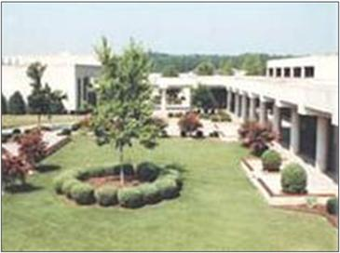

US Picture
Madoff's attorney asked the judge to recommend that the Federal Bureau of Prisons place Madoff in the Federal Correctional Institution, Otisville, which is located 70 miles (110 km) from Manhattan. The judge, however, only recommended that Madoff be sent to a facility in the Northeast United States. Madoff was transferred to the Federal Correctional Institution, Butner Medium, near Butner, North Carolina, about 45 miles (72 km) northwest of Raleigh; he is Bureau of Prisons Register #61727-054. Jeff Gammage of the Philadelphia Inquirer said "Madoff's heavy sentence likely determined his fate."
Madoff's projected release date is November 14, 2139. The release date, described as "academic" in Madoff's case, reflects a reduction for good behavior. On October 13, 2009, it was reported that Madoff experienced his first prison yard fight with another senior citizen inmate. When he began his sentence, Madoff's stress levels were so severe that he broke out in hives and other skin maladies soon after.
On December 18, 2009, Madoff was moved to Duke University Medical Center in Durham, North Carolina, and was treated for several facial injuries. A former inmate later claimed that the injuries were received during an alleged altercation with another inmate. Other news reports described Madoff's injuries as more serious and including "facial fractures, broken ribs, and a collapsed lung". The Federal Bureau of Prisons said Madoff signed an affidavit on December 24, 2009, which indicated that he had not been assaulted and that he had been admitted to the hospital for hypertension.
In his letter to his daughter-in-law, Madoff claimed that he was being treated in prison like a "Mafia don". "They call me either Uncle Bernie or Mr. Madoff. I can't walk anywhere without someone shouting their greetings and encouragement, to keep my spirit up. It's really quite sweet, how concerned everyone is about my well being, including the staff. . .It's much safer here than walking the streets of New York."

Catholic Church - Biggest Scam on the Face of the Earth
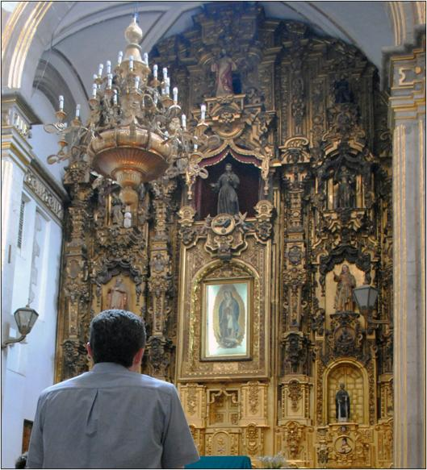
Interior del Convento de San Francisco, Centro Historico de la Ciudad de Mexico 20 August 2011

Author: ProtoplasmaKid - This file is licensed under the Creative Commons Attribution-Share Alike 3.0 Unported license.
Medieval religion with hocus pocus rituals that have evolved about 2000 years, by gay priests, bishops, and popes, and scammed the poorest people on the earth to donate 10% of their hard earned income to their gold covered buildings.
There isn’t much in the super biased Wikipedia website that I would want to share.
They profess to be using Jesus as one of their main idols, but they destroyed all that Jesus and Mary of Magdalene, wrote, killing thousands of people in their Crusades.
Their main idol is the supposed virgin Mary: 100% evolved bullshit. Other writers of the time mention that she was having sex at a very early age with her biological father, not some god.
Within this group of people, some individuals have been very good for humanity; but, they themselves have been brainwashed into the religion aspects. (PWW)
I will share one paragraph from Wikipedia:
Sex abuse cases: In the 1990s and 2000s, the issue of sexual abuse of minors by Catholic clergy became the subject of media coverage, legal action, and public debate in the United States, Ireland, Australia, and other countries. The Church was criticized for its handling of abuse complaints when it became known that some bishops had shielded accused priests, transferring them to other pastoral assignments where some continued to commit sexual offences. In response to the scandal, the Church has established formal procedures to prevent abuse, encourage reporting of any abuse that occurs and to handle such reports promptly, although groups representing victims have disputed their effectiveness. In September 2011, a submission was lodged with the International Criminal Court alleging that the Pope, Cardinal Angelo Sodano dean of the College of Cardinals, Cardinal Tarcisio Bertone Vatican Secretary of State, and Cardinal William Levada head of the Congregation of the Doctrine of the Faith, had committed a crime against humanity by failing to prevent or punish perpetrators of rape and sexual violence in a "systematic and widespread" concealment which included failure to co-operate with relevant law enforcement agencies.
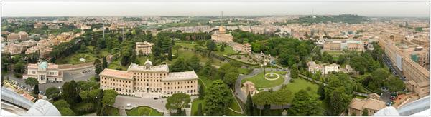
This panorama, shot from the top of St. Peter's Basilica, shows pretty much all that there is to Vatican City

Marcus Winter from Potsdam, Germany - This file is licensed under the Creative Commons Attribution-Share Alike 2.0 Generic license.
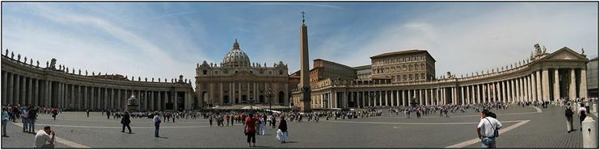
Panorama of St Peter's Square in Vatican City François Malan

This file is licensed under the Creative Commons Attribution-Share Alike 3.0 Unported license
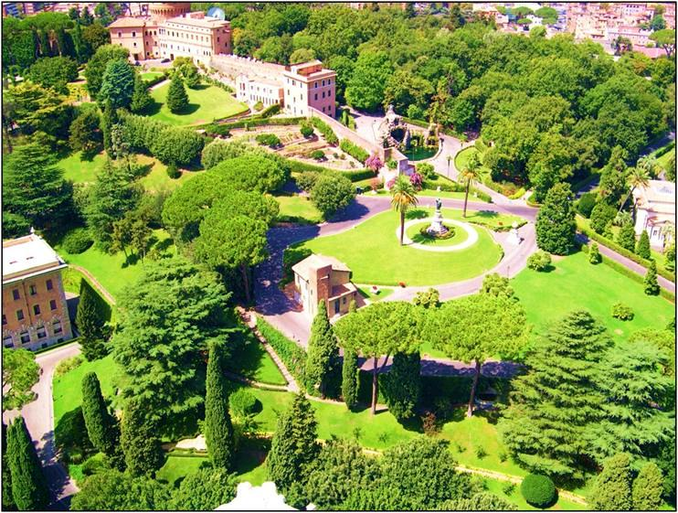
Photo of the Vatican Gardens 15 August 2007

Marek69 - This file is licensed under the Creative Commons Attribution-Share Alike 3.0 Unported license.

Where are all the gay priest today; oh, up in the housing area enjoying the altar boys. (PWW)

The Church of Jesus Christ of Latter-day Saints - Religion/Scammer/Huge Company
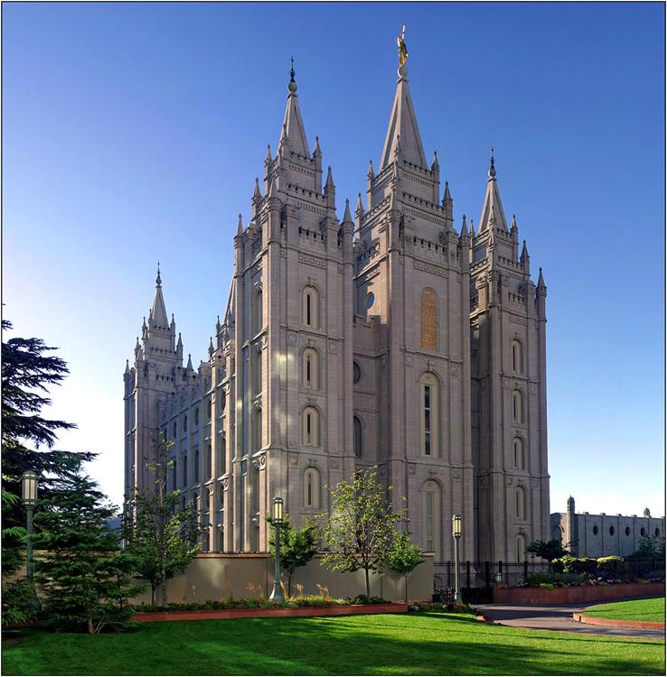
Salt Lake Temple in Salt Lake City, Utah, USA

This file is licensed under the Creative Commons Attribution 2.5 Generic license
The Church of Jesus Christ of Latter-day Saints (the LDS Church or, colloquially, the Mormon Church) is the largest denomination in the Latter Day Saint movement, a Christian primitivist movement started by Joseph Smith. The church is headquartered in Salt Lake City, Utah, and has established congregations and built temples worldwide. The church currently claims a growing membership of over 14.1 million.
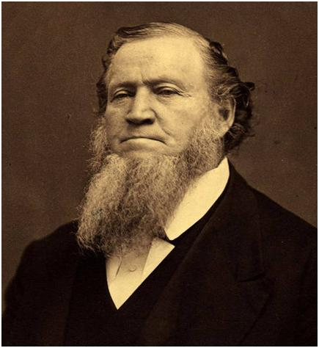
Brigham Young

This work is in the public domain in those countries with a copyright term of life of the author plus 80 years or fewer.
Under the doctrine of continuing revelation, Latter-day Saints believe that Jesus, under the direction of Heavenly Father, leads the church by revealing his will to its president, whom adherents regard as a modern-day "Prophet, seer, and revelator.” The current president is Thomas S. Monson.
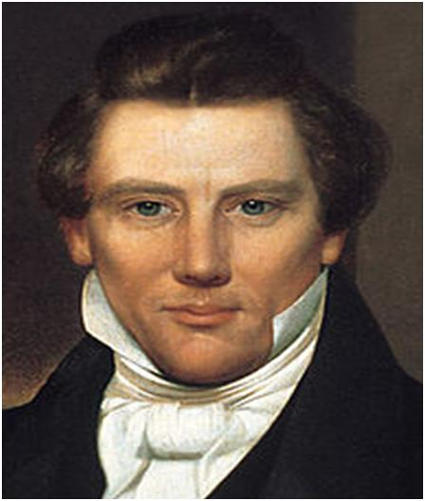
Painting by an unknown painter, circa 1842

This image (or other media file) is in the public domain because its copyright has expired in the US.

Faithful members contribute 10 percent of their income to the church as a tithe.
Finances:
Although the church has not released church-wide financial statements since 1959, in 1997, Time magazine called it one of the world's wealthiest churches per capita. In a June 2011 cover story, Newsweek magazine stated that the LDS church "Resembles a sanctified multinational corporation—the General Electric of American religion, with global ambitions and an estimated net worth of $30 billion.”
The church receives significant funds from tithes (ten percent of a member's income) and fast offerings (money given to the church to assist individuals in need). According to the church, tithing and fast offering moneys collected are devoted to ecclesiastical purposes and not used in for-profit ventures.
The church has also invested in for-profit business and real estate ventures such as Bonneville International, Deseret Book Company, and cattle ranches in Utah, Florida, Nebraska, Canada and other locations. However, these ranches are split between Church Welfare Work (Bishops' Storehouse and Welfare Square) for which funds are used from tithing and are not for profit.
Current U.S. politics: (2011)
Politically there are 15 Mormons in the current 112th United States Congress. This includes five U.S. Senators: Harry Reid (D-Nevada), Orrin Hatch (R-Utah), Mike Crapo (R-Idaho), Mike Lee (R-Utah), and Tom Udall (D-New Mexico); and ten U.S. Representatives: Rob Bishop (R-Utah), Jason Chaffetz (R-Utah), Jeff Flake (R-Arizona), Dean Heller (R-Nevada), Wally Herger (R-California), Raul Labrador (R-Idaho), Jim Matheson (D-Utah), Buck McKeon (R-California), Mike Simpson (R-Idaho), and Eni Faleomavaega (D-American Samoa).[116] There is one Mormon State Governor, Gary Herbert of Utah. Former Massachusetts governor Mitt Romney and former U.S. Ambassador to China Jon Huntsman, Jr. are both Mormon, and are vying for the 2012 Republican Party presidential nomination.
Officially, the current position of the church is that they will take no partisan role in politics. This means a hands-off approach to candidate races like those of Mitt Romney or Jon Huntsman, Jr. While the church takes an apolitical approach to the candidates themselves, it still actively works to counter anti-Mormonism that may come up during political campaigns. According to Michael Otterson, the LDS Church's managing director for public affairs, "We now have two Latter-day Saints running, and the potential for misunderstanding or missteps is therefore twice what it was before." However, the official church stance on staying out of politics does not include what church leaders feel are moral issues, and it has not been hesitant to endorse such political change.
Controversy and criticism:
The church has been subject to criticism and sometimes discrimination since its early years in New York and Pennsylvania. In the late 1820s, criticism centered around the claim by Joseph Smith, Jr. to have been led to a set of golden plates from which the Book of Mormon was reputedly translated. (True Religious-Bullshit PWW).
In the 1830s, the greatest criticism was for Smith's handling of a banking failure in Kirtland, Ohio, and the LDS Church's political and military power in Missouri, culminating in the 1838 Mormon War. In the 1840s, criticism of the church centered on the church's theocratic aspirations in Nauvoo, Illinois. Criticism of the practice of plural marriage and other doctrines taught by Smith appeared in the Nauvoo Expositor, which led to a series of events culminating in Smith's murder in 1844.
As the church began openly practicing plural marriage under Brigham Young during the second half of the 19th century, the church became the target of nation-wide criticism for that practice (which was banned by the church in 1890), as well as for the church's theocratic aspirations in the Utah Territory. Beginning in 1857, the church also came under significant media criticism after the Mountain Meadows massacre in southern Utah (They got rid of all the slaves that helped them move to Utah, so they would not breed their nice little blond girls).
Academic critics have questioned the legitimacy of Smith as a prophet as well as the historical authenticity of the Book of Mormon and the Book of Abraham. Criticism has expanded to include claims of historical revisionism, homophobia, racism, and sexist policies. Notable 20th-century critics include Jerald and Sandra Tanner and Fawn Brodie. Evangelical Christians continue to argue that Smith was either fraudulent or delusional.
In recent years, the Internet has provided a new forum for proponents and critics of Mormonism. The church's support in 2008 of California's Proposition 8 sparked heated debate and protest by gay-rights organizations and others. While the church remains opposed to same-sex marriage, it has come out in support of certain protections for members of the LGBT community in Salt Lake City, Utah.
Due to differences in doctrines, the LDS Church is generally considered to be distinct from historical Christianity by Catholic, Orthodox, and Protestant churches, which express differences from one another as well. Many have accused the LDS Church of not being a Christian church at all as a result of disagreements with Apostolic succession and the "Great Apostasy," the Nicene Creed and more so, Mormon cosmology and its plan of salvation including the doctrines of pre-mortal life, baptism for the dead, three degrees of heaven, and exaltation, the last of which allows for the belief that humans may become gods and goddesses achieving the same status that Jesus achieved, which is also referred to as becoming a "Joint-heir with Christ." (Give me money, and you get to live after you are dead! Scam. PWW)

Vincent Johnson - The Brooklyn Strangler

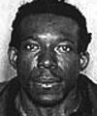

Mug shot of serial killer Vincent Johnson - Wikipedia

Between the summers of 1999 and 2000, a series of murders of prostitutes in the Williamsburg and Bedford-Stuyvesant neighborhoods of Brooklyn by Vincent Johnson, 5'3" (1.6 m) and 130 lb (59 kg).

Johnson initially refused to provide a DNA sample to police, and denied knowing any of the women. However, one of the detectives had observed him spitting on the street, and Johnson's saliva was retrieved and given to the medical examiner for testing. Johnson's DNA matched that which was found on four of the victims. Johnson later confessed to the murders of five women: Patricia Sullivan, Rhonda Tucker, Joanne Feliciano, Vivian Caraballo and Laura Nusser, all of whom had arrest records for prostitution and drug offenses, and were themselves addicts. He remained a suspect in the murder of Katrina Niles, although, as of 2006, he continues to deny involvement in her death. Police consider it likely he had sex with at least three of his victims.

Johnson reportedly claimed he was acting out a hatred of his mother. Three of the victims — Caraballo, Feliciano and Sullivan — were killed on Thursdays, and Rhonda Tucker probably was as well, although her body was discovered on a Saturday. According to Johnson, this deliberate fixation came about due to his loathing of his mother's one day off from work, always a Thursday.

Johnson admitted little, if any, feelings of guilt. Of Patricia Sullivan, he said, "I didn't see strangling her as doing something wrong at the time"; although after killing his first victim, Laura Nusser, he said he reported feeling "sorry" and wanting to apologize to her family.

Each of the victims was strangled, apparently with whatever ligature was at hand: two with their own shoelaces, one with a drawstring from a pair of sweatpants, two with electrical wire and one with what was probably a discarded piece of cloth. Johnson bound their bodies with the ligatures, but did not attempt to hide them. The women were left where they were killed, two on rooftops and one in a vacant lot in roughly the same vicinity in Williamsburg, two in apartments in Bedford-Stuyvesant, and one in a utility room under the Williamsburg Bridge, where Johnson was known to have slept occasionally on a cot.

Johnson is currently serving a life sentence without parole in Clinton Correctional Facility, in Dannemora, New York.

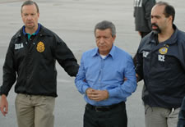

Walmart - Sam Walton – Greedy Businessman

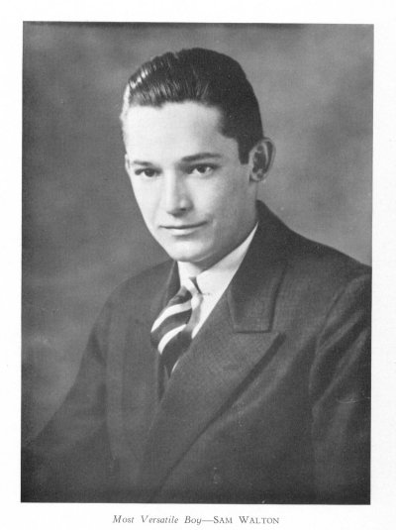

Sam Walton voted most versatile boy in the David H. Hickman High School yearbook in 1936

The yearbook (The Cresset) was published with no copyright notice and is now in the public domain of the United States.

Samuel Moore "Sam" Walton (March 29, 1918 – April 5, 1992) was a businessman, entrepreneur, and Eagle Scout born in Kingfisher, Oklahoma best known for founding the retailers Wal-Mart and Sam's Club.

Wal-Mart Stores, Inc. (NYSE: WMT), branded as Walmart since 2008 and Wal-Mart before then, is an American public multinational corporation that runs chains of large discount department stores and warehouse stores. The company is the world's 18th largest public corporation, according to the Forbes Global 2000 list, and the largest public corporation when ranked by revenue. It is also the biggest private employer in the world with over 2 million employees, and is the largest company in the world.

The company was founded by Sam Walton in 1962, incorporated on October 31, 1969, and publicly traded on the New York Stock Exchange in 1972. It is headquartered in Bentonville, Arkansas. Walmart is also the largest grocery retailer in the United States. In 2009, it generated 51% of its US$258 billion sales in the U.S. from grocery business. It also owns and operates the Sam's Club retail warehouses in North America.

A Loyola University Chicago study which suggested that impact a Wal-Mart store has on a local business is correlated to its distance from that store. The leader of that study admits that this factor is stronger in smaller towns and doesn't apply to more urban areas saying "It'd be so tough to nail down what's up with Wal-Mart". Another study found Wal-Mart's entry into a new market has a profound impact on its retail competition. When a Wal-Mart opens in a new market, median sales drop 40% at similar high-volume stores, 17% at supermarkets and 6% at drugstores, according to a June 2009 study by researchers at several universities and led by the Tuck School of Business at Dartmouth College.

Labor unions, Christian organizations, and environmental groups have criticized Wal-Mart for its policies and/or business practices. In particular, several labor unions blame Wal-Mart workers' unwillingness to join their organizations on the company's anti-union stance. Others disapprove of the corporation's extensive foreign product sourcing, (Chinese crap) treatment of employees and product suppliers, environmental practices, and use of public subsidies, and the impact of stores on the local economies of towns in which they operate. (Walmart stores do not carry CDs and DVDs that do not fit their religious beliefs. PWW)

In 2005, two national campaigns to criticize Wal-Mart were launched: the (United Food and Commercial Workers) launched Wake Up Wal-Mart and The Center for Community and Corporate Ethics launched Wal-Mart Watch. By the end of 2005, Wal-Mart launched Working Families for Wal-Mart, an operation managed by Wal-Mart to tell the company's side of the story. Additional efforts to counter criticism included a PR campaign in 2005, managed through its PR website walmartfacts.com, as well as several television commercials. The company retained the PR firm Edelman to respond to negative media attention, and started interacting directly with bloggers by sending them news, suggesting topics for postings, and sometimes inviting them to visit its corporate headquarters. Similarly, in 2010, several of Wal-Mart's opponents have hired The Saint Consulting Group to support grass-roots campaigns against Wal-Mart. The most notable of these include grocery chains such as Safeway Inc., SuperValu, and Ahold, concerned that the presence of Wal-Mart will add more competition to their operations. (Good clean competition is good. PWW)

In June 2006, Walmart was excluded from the investment portfolio of The Government Pension Fund of Norway, which held stock values of about US$ 430 million in the company, due to a social audit into alleged labor rights violations in the company's operations in the US and worldwide. Although Walmart did not respond to questions from the fund's auditors, the company later claimed the decision "don't appear to be based on complete information.”

In the past, Wal-mart has been accused of locking night-shift workers in at night, paying employees below minimum wage, and exposing employees to health hazards. Wal-Mart's own "Standards for Suppliers" reports document extensive problems of this kind among the company's "directly-sourced" factories. Full-time Wal-Mart employees earn an average of $10.78 per hour, but critics point out that the starting pay can be far lower — placing some employees with children below the poverty line — and that pay rates do not rise as quickly as with unionized companies. Others decry low levels of health coverage or overpriced health insurance, though the company reports that it offers rates as low as $5 per month in some areas ($9 per month nationwide) and that 92% of its associates are insured (though not necessarily through Wal-Mart). Other grievances regard poor working conditions, unfavorable employer-employee relationships, and anti-union policies. Many suggest that Wal-Mart's high annual turnover-rate of ~70% shows that workers are dissatisfied and maltreated.

Wal-Mart has opposed the Employee Free Choice Act (EFCA), which would make it easier for workers to unionize by removing the employer's ability to demand a secret ballot in union elections, and which would require mandatory arbitration of labor disputes. In mid-2008, the company required store managers and department heads to attend meetings at which opposition to the EFCA was used as a fulcrum for criticism of Democratic candidates in the elections for the United States Senate and the House of Representatives, as well as of the presumptive Democratic Presidential nominee, Senator Barack Obama. At these meetings, Wal-Mart human resources managers warned that Democratic victories might result in passage of the EFCA and hence more unionization. At one meeting, a Wal-Mart customer service supervisor from Missouri stated, "I am not telling you how to vote, but if the Democrats win, this bill will pass and you won't have a vote on whether you want a union. A Wal-Mart spokesman, while acknowledging that the meetings were taking place nationwide, said, "If anyone representing Wal-Mart gave the impression we were telling associates how to vote, they were wrong and acting without approval." Several labor-rights groups including the AFL-CIO have asked the Federal Election Commission to investigate whether Wal-Mart broke federal election rules by advocating against Democratic candidate Barack Obama in meetings with employees.

According to a Newsweek article, Wal-Mart, after years of fierce fighting, accepted organized labor in China. Labor unions in China do not negotiate contracts, but rather they are an arm of the state "to secure the social order" and provide funding to the Communist Party.

Gender and sexual orientation:

In 2007, a gender discrimination lawsuit, Dukes v. Wal-Mart Stores, Inc., was filed against Walmart, alleging that female employees were discriminated against in matters regarding pay and promotions. A class action suit was sought, which would have been the nation's largest in history, covering 1.5 million past and current employees of Wal-Mart. On June 20, 2011, the United States Supreme Court ruled in Wal-Mart's favor, stating that the plaintiffs did not have enough in common to constitute a class. The court ruled unanimously that because of the variability of the plaintiffs' circumstances, the class action could not proceed as presented, and furthermore, in a 5-4 decision that it could not proceed as any kind of class action suit. However, several plaintiffs, including Ms. Dukes, still intend to file individual discrimination lawsuits separately.

According to a consultant hired by plaintiffs in a sex discrimination lawsuit, in 2001, Wal-Mart's EEOC filings showed that female employees made up 65% of Wal-Mart's hourly paid workforce, but only 33% of its management. Just 35% of its store managers were women, whereas 57% were at comparable retailers. Wal-Mart says comparisons with other retailers are unfair, because it classifies employees differently; if department managers were included in the totals, women would make up 60% of the managerial ranks. Others have criticized the lawsuit as without basis in the law and as an abuse of the class action mechanism. In 2007, Wal-Mart was named by the National Association for Female Executives as one of the top 35 companies for Executive Women.

Mislabeling:

Since opening in 2006 in China, the company has been punished 21 times for false advertising, for selling expired food or not passed safety inspections. And on October 2011, two Wal-Mart Stores Inc. employees arrested in Chinese mislabelling probe of ordinary pork as organic made the Chongging government fined the retailer 3.65 million Yuan ($574,000).

Medellín Cartel – Drug Movers – Gangbangers

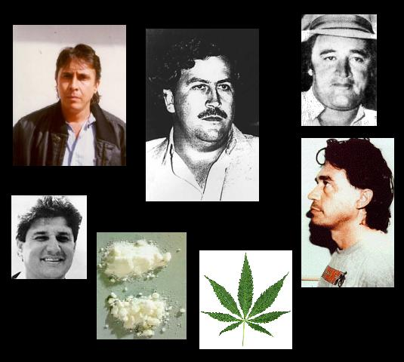

Medellin Cartel members, marihuana and cocaine images

Public Domain images. – Author: Amnesico29 – Wikipedia

The Medellín Cartel was an organized network of "drug suppliers and smugglers" originating in the city of Medellín, Colombia. The drug cartel operated in Colombia, Bolivia, Peru, Central America, the United States, as well as Canada and even Europe throughout the 1970s and 1980s. It was founded and run by Ochoa Vázquez brothers Jorge Luis, Juan David, and Fabio together with Pablo Escobar. By 1993, the Colombian government, helped by the US, had successfully dismantled the cartel by imprisoning or hunting and gunning down its members.

During the height of its operations, the cartel brought in more than $60 million per day. The total amount of money made by the cartel was in the tens of billions, and very possibly the hundreds of billions of dollars. There were many "groups" during the cartel's years, usually white Americans, Canadians or Europeans, organized for the sole purpose of transporting shipments of cocaine destined for the United States, Europe and Canada. While many groups were infiltrated and taken down by Federal agents and informers, a few were stumbled upon by authorities, usually due to some small misstep or careless behavior by a group member. (Some of my friends/acquaintances/pilots flew DC-3s and DC-6s down to Colombia in those days, making a lot of money. One group tried to rob the cartel; they never returned, and their plane landed in the ocean with no one aboard. PWW)

Once authorities were made aware of "questionable activities", the group would be put under Federal Drug Task Force surveillance. Evidence would be gathered, compiled and presented to a Grand Jury, resulting in indictments, arrests and prison sentences, for those convicted. The number of Colombian Cartel Leaders actually taken into custody as a result of these operations, was very few. Mostly non-Colombians, conspiring with the Cartel, were the "fruits" of these indictments.

Most Colombians targeted, as well as those named in such indictments, lived and stayed in Colombia, or fled before indictments were unsealed. However, by 1993 most, if not all, cartel fugitives had been imprisoned or hunted and gunned down by the Colombian National Police trained and assisted by U.S. Delta Force units and the CIA.

While it is broadly believed that the group "Los Pepes" have been instrumental in the assassination of the cartel's members over the last 17 years, it is still in dispute whether the mantle is just a screen designed to deflect political repercussions from both the Colombian and United States governments involvement in these assassinations. (Some good FICTIONAL stories are in my books, patterned after some of the activities of the involved groups. PWW)

The cartel and terrorism:

On August 18, 1989, the cartel murdered leading presidential candidate Luis Carlos Galán, and declared "total and absolute war" against the Colombian government, seeking to stop potential extradition of its members. The strategy consisted of terrorizing the civilian population and cornering the government. The cartel conducted hundreds of terrorist attacks against civilian and governmental targets. However, the cartel had already started a campaign of assassinations of key political figures, as far back as 1984.

The following is a list of the most notable incidents involving the Medellín cartel:

May 30, 1989: Attempted assassination of Miguel Maza Marquez, director of the Departamento Administrativo de Seguridad (DAS) in Bogotá. Car bomb. 4 dead, 37 injured.

September 2, 1989: Car bomb against major newspaper El Espectador in Bogotá; 84 wounded. Guillermo Cano Isaza, director of the newspaper had been killed on Escobar's orders on December 17, 1986.

October 16, 1989: Car bomb against newspaper Vanguardia Liberal, in Bucaramanga; four killed.

November 27, 1989: The cartel bombs Avianca Flight 203 during flight over Bogotá while attempting to kill presidential candidate César Gaviria Trujillo, who had not boarded the plane; 110 are killed.

December 6, 1989: DAS headquarters in downtown Bogotá is bombed with over 1,100 pounds of explosives during the morning rush. The attack kills over 50, injures more than 600, and levels several city blocks, destroying more than 300 commercial properties.

May 13, 1990: Two bombs detonate separately at the Quirigua and Niza shopping malls during Mother's Day in Bogotá, killing 14 and wounding over 100.

February 16, 1991: The cartel detonates a 440-pound car bomb outside La Macarena, a Bullring in Medellín; killing 22.

January 30, 1993: A car bomb in downtown Bogotá kills 20. The bomb was set off in a high-rise area, and most of the dead were in higher floors as the explosive wave traveled up the buildings.

April 15, 1993: A car bomb kills 15 and injures over 100 outside the Centro 93 shopping mall in northern Bogotá.

Assassinations:

As a means of intimidation, the cartel conducted several hundred assassinations throughout the country. Escobar and his associates made it clear that whoever stood against them would risk being killed along with his/her families. Some estimates put the total around 3,500 killed during the height of the cartel, including over 500 police officers in Medellín, but the entire list is impossible to assemble, due to the limitation of the judiciary power in Colombia.

The following is a brief list of the most notorious assassinations conducted by the cartel:

Luis Vasco and Gilberto Hernandez, two DAS agents who had arrested Pablo Escobar in 1976; one of the earliest assassinations of authority figures by the cartel.

Rodrigo Lara Bonilla, Minister of Justice, killed on a Bogotá highway on April 30, 1984 when two gunmen riding a motorcycle approached his vehicle in traffic and opened fire.

Tulio Manuel Castro Gil, Superior Judge, killed by motorcycle gunmen in July 1985 shortly after indicting Escobar.

Hernando Baquero Borda, Supreme Court Justice, killed by gunmen in Bogotá on July 31, 1986.[19]

Jaime Ramírez, Police Colonel and head of the anti-narcotics unit of the National Police of Colombia. Killed on a Medellín highway in November 1986 when assassins in a red Renault pulled up beside his white Toyota minivan and opened fire. Ramírez was killed instantly; his wife and two sons were wounded.

Guillermo Cano Isaza, director of El Espectador, killed on December 1986 in Bogotá by gunmen riding a motorcycle.

Jaime Pardo Leal, presidential candidate and head of the Patriotic Union party, killed by a gunman on October, 1987.

Carlos Mauro Hoyos, Attorney General, killed by gunmen in Medellín on January 1988.

Antonio Roldan Betancur, governor of Antioquia, killed by a car bomb in July 1989.

Valdemar Franklin Quintero, Commander of the Antioquia police, killed by gunmen in Medellín in August, 1989.

Luis Carlos Galán, presidential candidate, killed by gunmen during a rally in Soacha in August, 1989. The assassination was carried out on the same day the commander of the Antioquia police was gunned down by the cartel.

Carlos Ernesto Valencia, Superior Judge, killed by gunmen shortly after indicting Escobar on the death of Guillermo Cano, in August 1989.

Jorge Enrique Pulido, journalist, director of JEP Television, killed by gunmen in Bogotá in November 1989.

Diana Turbay, journalist, chief editor of the Hoy por Hoy magazine, killed during a rescue attempt in January 1991.

Enrique Low Murtra, Minister of Justice, killed by gunmen in downtown Bogotá on May 1991.

Myriam Rocio Velez, Superior Judge, killed by gunmen shortly before she was to sentence Escobar on the assassination of Galan, in September 1992.

End of the cartel:

The cartel's violence earned it the enmity of the Colombian and U.S. governments in addition to that of its rival Cali Cartel.

Many members of the cartel, including Pablo Escobar, were hunted and killed by a National Police of Colombia force, the Search Bloc, which had been trained and assisted by both the U.S. Delta Force as well as the CIA. Escobar's cartel associates were also targeted by the Los Pepes vigilante group.

DEA Agents considered that their four-pronged 'Kingpin Strategy', specifically targeting senior cartel figures, was a major contributing factor to the collapse of the organization.

Cali Cartel – Drug Movers – Gangbangers

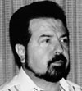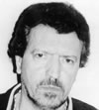

Gilberto Rodriguez Orejuela & Miguel Rodriguez Orejuela This image or file is a work of a Drug Enforcement Administration employee, taken or made during the course of an employee's official duties. As a work of the U.S. federal government, the image is in the public domain.

The Cali Cartel was a drug cartel based in southern Colombia, around the city of Cali and the Valle del Cauca Department. The Cali Cartel was founded by the Rodríguez Orejuela brothers, Gilberto and Miguel, as well as associate José Santacruz Londoño. Later Cali cartel principals included Hélmer Herrera, Jairo Ivan Urdinola Grajales, Julio Fabio Urdinola Grajales, Henry Loaiza Ceballos, Victor Patiño Fomeque, Phanor Arizabaleta Arzayus, Raul Grajales Lemos, Luis Grajales Posso, Bernardo Saenz, Juan Carlos Ortiz Escobar, Jose Quervo, Javier Marlin Rojas, and James Andrae.

The Cali Cartel was formed by the Rodriguez brothers and Santacruz, all coming from what is described as a higher social background than most other traffickers of all time. The recognition of this social background was displayed in the group's nickname as "Cali's Gentlemen."

The group originally assembled as a ring of kidnappers known as Las Chemas, which was led by Luis Fernando Tamayo Garcia. Las Chemas were implicated in numerous kidnappings including that of two Swiss citizens, a diplomat Herman Buff and a student, Zack Jazz Milis Martin. They reportedly received $700,000 dollars in ransom, which is believed to have gone on to fund their drug trafficking empire.

The assembled group first involved itself in trafficking marijuana. Due to the products low profit rate, and larger amount required to traffic to cover resources, the fledgling group decided to shift their focus to the more lucrative drug: cocaine.

In the early 1970s the cartel sent Helmer "Pacho" Herrera to New York City to establish a distribution center. This action came during a time when the United States Drug Enforcement Administration (DEA) was not fully pursuing cocaine, and viewed the drug as less critical than heroin, at one point releasing a report stating of cocaine it "is not physically addictive ... and does not usually result in serious consequences, such as crime, hospital emergency room admissions or both."

Image of Miguel Rodriguez-Orejuela being escorted by DEA and ICE agents

This image is a work of a United States Department of Justice employee, taken or made as part of that person's official duties. As a work of the U.S. federal government, the image is in the public domain.

Vladimir Putin - Past Russian President

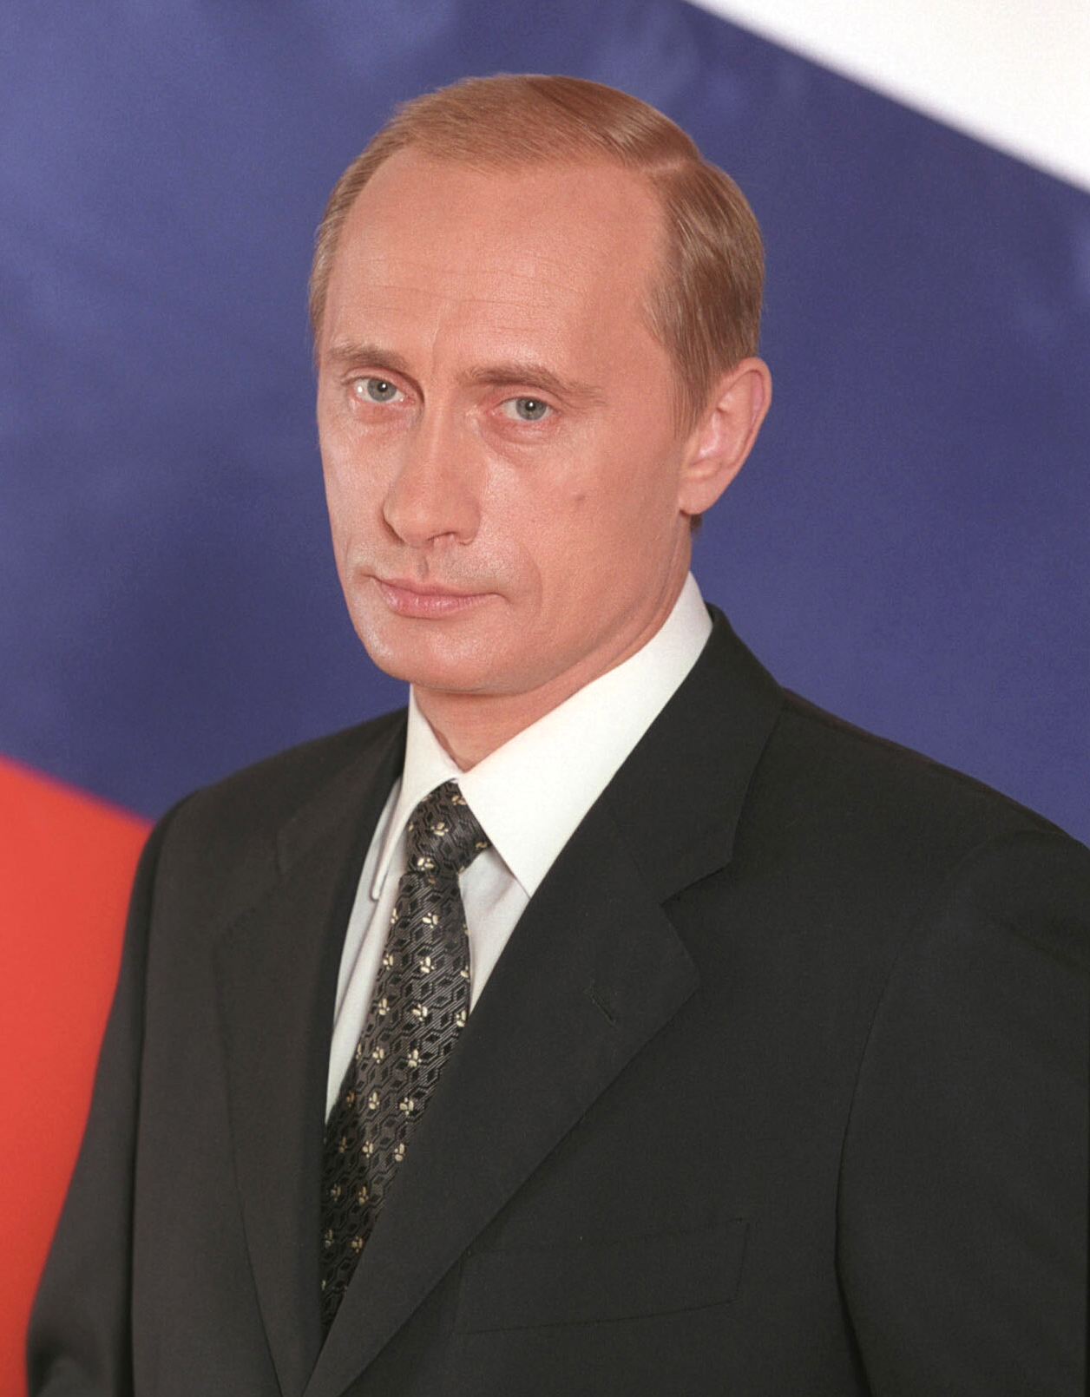
Official portrait of Vladimir Putin - Presidential Press and Information Office
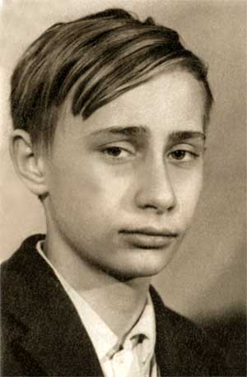
Vladimir Putin at school age - This file comes from the website of the President of the Russian Federation and is copyrighted. This file is licensed under the Creative Commons Attribution 3.0 Unported Licence. In short: you are free to distribute and modify the file as long as you attribute www.kremlin.ru.
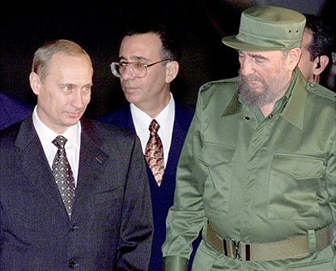
President Vladimir Putin with Cuban leader Fidel Castro during a welcoming ceremony at the airport - This file comes from the website of the President of the Russian Federation and is copyrighted. This file is licensed under the Creative Commons Attribution 3.0 Unported Licence. In short: you are free to distribute and modify the file as long as you attribute www.kremlin.ru.
Vladimir Vladimirovich Putin, born 7 October 1952) served as the second President of the Russian Federation and is the current Prime Minister of Russia, as well as chairman of United Russia and Chairman of the Council of Ministers of the Union of Russia and Belarus. He became acting President on 31 December 1999, when president Boris Yeltsin resigned in a surprising move. Putin won the 2000 presidential election and in 2004 he was re-elected for a second term lasting until 7 May 2008.
Because of constitutionally mandated term limits, Putin was ineligible to run for a third consecutive presidential term. After the victory of his successor, Dmitry Medvedev, in the 2008 presidential elections, Putin was nominated by Medvedev to be Russia's Prime Minister; Putin took the post on 8 May 2008. In September 2011, Putin officially announced that he will seek a third non-consecutive term in the 2012 presidential elections.
Putin is credited with bringing political stability and re-establishing the rule of law in the country. He successfully restored the territorial integrity of Russia in the Second Chechen War. During Putin's presidency, Russia's economy bounced back from crisis, growing for nine straight years and seeing GDP increase by 72% in PPP (sixfold in nominal), poverty decrease by more than 50%, and average monthly salaries increase from $80 to $640. These achievements were ascribed to strong macroeconomic management, important fiscal policy reforms and a confluence of high oil prices, surging capital inflows and access to low-cost external financing, and were described as impressive by analysts.
During his presidency, Putin passed into law a series of fundamental reforms, including a flat income tax of 13%, a reduced profits tax, and new land and legal codes. He put much effort into development of the energy policy of Russia, affirming Russia's position as an energy superpower. This included the renaissance of the nuclear industry in the country and the initiation of construction of several major export pipelines, including ESPO and Nord Stream, among other megaprojects in Russia.
While many reforms and actions made during the Putin presidency have been criticized by Western observers and domestic opposition as un-democratic, Putin's leadership over the return of order, stability, and progress has won him widespread popularity in Russia. Putin often supports a tough guy image in the media, demonstrating his physical capabilities and taking part in unusual or dangerous acts, such as extreme sports and interaction with wild animals. A judoka and a Champion of Leningrad in his youth, Putin has played a major role in development of sport in Russia, notably, helping the city of Sochi to win the bid for the 2014 Winter Olympics.
Religion:
Putin's father was "a model communist, genuinely believing in its ideals while trying to put them into practice in his own life". With this dedication he became secretary of the Party cell in his workshop and then after taking night classes joined the factory’s Party bureau. Though his father was a "militant atheist", Putin's mother "was a devoted Orthodox believer". Though she kept no icons at home, she attended church regularly, despite the government's persecution of the Russian Orthodox Church at that time. She ensured that Putin was secretly christened as a baby and she regularly took him to services. His father knew of this but turned a blind eye. According to Putin's own statements, his religious awakening followed the serious car crash of his wife in 1993, and was deepened by a life-threatening fire that burned down their dacha in August 1996. Right before an official visit to Israel, his mother gave him his baptismal cross telling him to get it blessed “I did as she said and then put the cross around my neck. I have never taken it off since.” Putin repeated the story to George W. Bush in June 2001, which might have inspired Bush to make his remark that he had "got a sense of Putin's soul". When asked whether he believes in God during his interview with Time, he responded saying: "... There are things I believe, which should not in my position, at least, be shared with the public at large for everybody's consumption because that would look like self-advertising or a political striptease."
Personal wealth:
According to the data submitted during the legislative election of 2007, Putin's wealth was limited to approximately 3.7 million rubles (approximately $150,000) in bank accounts, a private 77.4-square-meter (833 sq ft) apartment in Saint Petersburg, 260 shares of Bank Saint Petersburg (with a December 2007 market price $5.36 per share) and two 1960s Volga M21 cars that he inherited from his father and does not register for on-road use. Putin's 2006 income totaled 2 million rubles (approximately $80,000). According to the data Putin did not make it into the 100 wealthiest Duma candidates of his own United Russia party.
There have also been allegations that Putin secretly owns a large fortune. According to former Chairman of the Russian State Duma Ivan Rybkin, in 2004, and Russian political scientist Stanislav Belkovsky, Putin allegedly controlled a 4.5% stake (approx. $13 billion) in Gazprom, 37% (approx. $20 billion) in Surgutneftegaz and 50% in the oil-trading company Gunvor. Gunvor's turnover in 2007 was $40 billion. The aggregate estimated value of these holdings would easily make Putin Russia's richest person. In December 2007, Belkovsky elaborated on his claims: "Putin's name doesn't appear on any shareholders' register, of course. There is a non-transparent scheme of successive ownership of offshore companies and funds. The final point is in Zug, Switzerland, and Liechtenstein. Vladimir Putin should be the beneficiary owner." Asked at a press conference on 14 February 2008 whether he was the richest person in Europe, as some newspapers claimed; and if so, to state the source of his wealth, Putin said "This is true. I am the richest person not only in Europe, but also in the world. I collect emotions; and I am rich in that respect that the people of Russia have twice entrusted me with leadership of such a great country as Russia. I consider this to be my biggest fortune. As for the rumors concerning my financial wealth, I have seen some pieces of paper regarding this. This is plain chatter, not worthy discussion, plain bosh. They have picked this in their noses and have smeared this across their pieces of paper. This is how I view this."

Evidence in support of the allegations of Belkovsky and others was provided in December 2010 and the early months of 2011 by Sergei Kolesnikov, a businessman with ties to Putin dating from his time in St. Petersburg. In an open letter to Dmitri Medvedev and in media interviews he claimed that he and other named individuals had participated in a scheme that involved a proportion of donations from businessmen including Roman Abramovich and Alexei Mordashov, ostensibly intended for health infrastructure projects, being siphoned off into a Switzerland-based investment fund managed for Putin's benefit. Besides more conventional investments, the fund was allegedly used for the construction of a large Italianate palace for Putin's personal use, nicknamed Putin's Palace, located on the Black Sea coast near the village of Praskoveevka in Krasnodar Krai, Russia. Kolesnikov also claimed that state resources were illegitimately used for the palace's construction. The Kremlin issued a denial of the allegations, which has subsequently been undermined by the investigative journalism of Novaya Gazeta, which found a paper trail leading to the Kremlin.

Construction work on "Putin's Palace", near the village of Praskoveevka in Krasnodar Krai, Russia 18 January 201, Source http://ruleaks.net/1901 Author Russian Wikileaks - This file is licensed under the Creative Commons Attribution 3.0 Unported license.

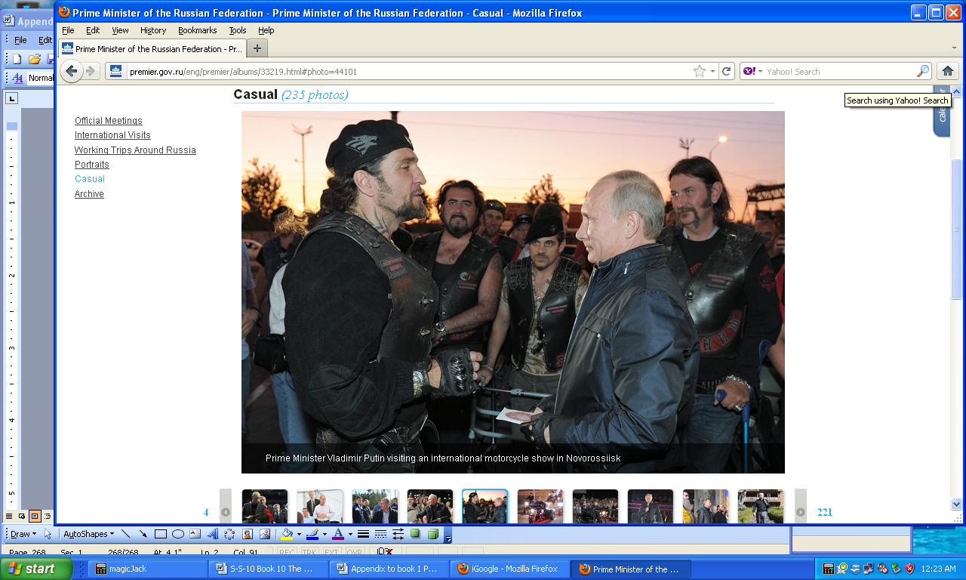
http://premier.gov.ru/eng/premier/albums/33219.html#photo=44101

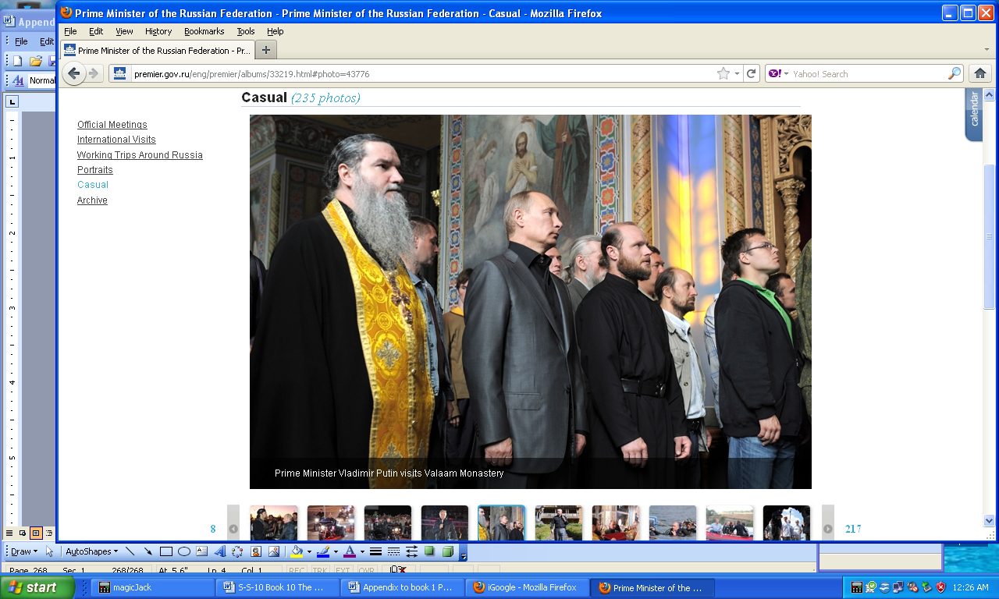

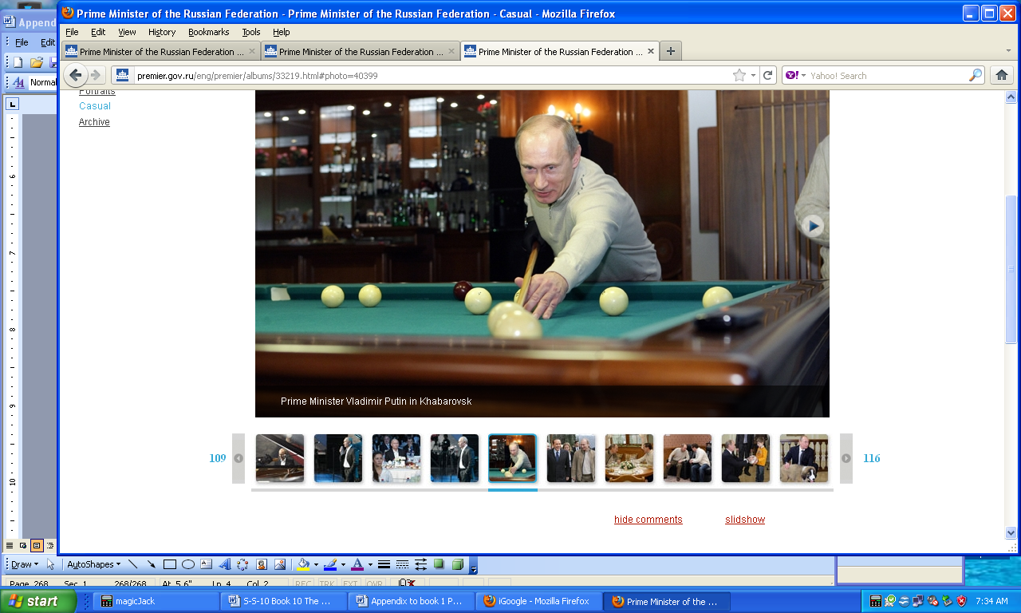
http://premier.gov.ru/eng/premier/albums/

Kerkor "Kirk" Kerkorian
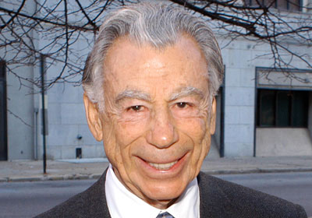
Low resolution copy from Forbes Magazine; No other non copyright picture available.
Kerkor "Kirk" Kerkorian (born June 6, 1917) is an American businessman who is the president/CEO of Tracinda Corporation, his private holding company based in Beverly Hills, California. Kerkorian is known as one of the important figures in shaping Las Vegas and, with architect Martin Stern, Jr. the "father of the mega-resort."
Kerkorian and Las Vegas:
In 1962, Kerkorian bought 80 acres (32 ha) in Las Vegas, across The Strip from the Flamingo, for $960,000. This purchase led to the building of Caesars Palace, which rented the land from Kerkorian; the rent and eventual sale of the land to Caesars in 1968 made Kerkorian $9 million.
In 1967, he bought 82 acres (33 ha) of land on Paradise Road in Las Vegas for $5 million and, with architect Martin Stern, Jr., built the International Hotel, which at the time was the largest hotel in the world; The first two performers to appear at the hotel's enormous Showroom Internationale were Barbra Streisand and Elvis Presley. Presley brought in some 4,200 customers (and potential gamblers), every day, for 30 days straight, breaking in the process all attendance records in the county's history. Kerkorian's International Leisure also bought the Flamingo Hotel (which later sold the Flamingo to the Hilton Hotels Corporation in 1970). The International Hotel is known today as the Las Vegas Hilton. Until about 2000, the Flamingo was known as the Flamingo Hilton.
After he purchased the MGM movie studio in 1969, Kerkorian (with architect Martin Stern Jr.) opened the original MGM Grand Hotel and Casino, larger than the Empire State Building and the largest hotel in the world at the time it was finished. On November 21, 1980, the original MGM Grand burned in a fire that was one of the worst disasters in Las Vegas history. The Clark County Fire Department reported 84 deaths in the fire; there were 87 deaths total, including three which occurred later as a result of injuries sustained in the fire. Amazingly, the MGM Grand reopened after only 8 months. Almost three months after the MGM fire, the Las Vegas Hilton caught fire, killing eight people.
In 1986, Kerkorian sold the MGM Grand hotels in Las Vegas and Reno for $594 million to Bally Technologies. The Las Vegas property was subsequently renamed Bally's. Spun off from Metro-Goldwyn-Mayer, MGM Resorts International owns and operates several properties, including the Bellagio, the current MGM Grand resort complex, The Mirage, the New York-New York, Circus Circus, Mandalay Bay, The Luxor, Excalibur and the newly completed CityCenter in Las Vegas.
MGM sold its Treasure Island Hotel and Casino property to billionaire and former New Frontier owner Phil Ruffin for $750 million.
Wealth:
His net worth in 2008, according to Forbes magazine, was $16.0 billion, making him the world's 41st richest person at that time. By 2011, Kerkorian was among those hardest hit by stock market recession as his net worth tumbled to $3.2 billion. He is currently listed as the 310th richest person.

Walmart - Sam Walton - - Super Greedy Businessman

Sam Walton voted most versatile boy in the David H. Hickman High School yearbook in 1936

The yearbook (The Cresset) was published with no copyright notice and is now in the public domain of the United States.

Samuel Moore "Sam" Walton (March 29, 1918 - - April 5, 1992) was a businessman, entrepreneur, and Eagle Scout born in Kingfisher, Oklahoma best known for founding the retailers Wal-Mart and Sam's Club.

Wal-Mart Stores, Inc. (NYSE: WMT), branded as Walmart since 2008 and Wal-Mart before then, is an American public multinational corporation that runs chains of large discount department stores and warehouse stores. The company is the world's 18th largest public corporation, according to the Forbes Global 2000 list, and the largest public corporation when ranked by revenue. It is also the biggest private employer in the world with over 2 million employees, and is the largest company in the world.

The company was founded by Sam Walton in 1962, incorporated on October 31, 1969, and publicly traded on the New York Stock Exchange in 1972. It is headquartered in Bentonville, Arkansas. Walmart is also the largest grocery retailer in the United States. In 2009, it generated 51% of its US$258 billion sales in the U.S. from grocery business. It also owns and operates the Sam's Club retail warehouses in North America.

A Loyola University Chicago study which suggested that impact a Wal-Mart store has on a local business is correlated to its distance from that store. The leader of that study admits that this factor is stronger in smaller towns and doesn't apply to more urban areas saying "It'd be so tough to nail down what's up with Wal-Mart". Another study found Wal-Mart's entry into a new market has a profound impact on its retail competition. When a Wal-Mart opens in a new market, median sales drop 40% at similar high-volume stores, 17% at supermarkets and 6% at drugstores, according to a June 2009 study by researchers at several universities and led by the Tuck School of Business at Dartmouth College.

Labor unions, Christian organizations, and environmental groups have criticized Wal-Mart for its policies and/or business practices. In particular, several labor unions blame Wal-Mart workers' unwillingness to join their organizations on the company's anti-union stance. Others disapprove of the corporation's extensive foreign product sourcing, (Chinese crap) treatment of employees and product suppliers, environmental practices, and use of public subsidies, and the impact of stores on the local economies of towns in which they operate. (Walmart stores do not carry CDs and DVDs that do not conform to their religious beliefs. PWW)

In 2005, two national campaigns to criticize Wal-Mart were launched: the (United Food and Commercial Workers) launched Wake Up Wal-Mart and The Center for Community and Corporate Ethics launched Wal-Mart Watch. By the end of 2005, Wal-Mart launched Working Families for Wal-Mart, an operation managed by Wal-Mart to tell the company's side of the story. Additional efforts to counter criticism included a PR campaign in 2005, managed through its PR website walmartfacts.com, as well as several television commercials. The company retained the PR firm Edelman to respond to negative media attention, and started interacting directly with bloggers by sending them news, suggesting topics for postings, and sometimes inviting them to visit its corporate headquarters. Similarly, in 2010, several of Wal-Mart's opponents have hired The Saint Consulting Group to support grass-roots campaigns against Wal-Mart. The most notable of these include grocery chains such as Safeway Inc., SuperValu, and Ahold, concerned that the presence of Wal-Mart will add more competition to their operations. (Good clean competition is good. PWW)

In June 2006, Walmart was excluded from the investment portfolio of The Government Pension Fund of Norway, which held stock values of about US$ 430 million in the company, due to a social audit into alleged labor rights violations in the company's operations in the US and worldwide. Although Walmart did not respond to questions from the fund's auditors, the company later claimed the decision "don't appear to be based on complete information.”

In the past, Wal-mart has been accused of locking night-shift workers in at night, paying employees below minimum wage, and exposing employees to health hazards. Wal-Mart's own "Standards for Suppliers" reports document extensive problems of this kind among the company's "directly-sourced" factories. Full-time Wal-Mart employees earn an average of $10.78 per hour, but critics point out that the starting pay can be far lower — placing some employees with children below the poverty line — and that pay rates do not rise as quickly as with unionized companies. Others decry low levels of health coverage or overpriced health insurance, though the company reports that it offers rates as low as $5 per month in some areas ($9 per month nationwide) and that 92% of its associates are insured (though not necessarily through Wal-Mart). Other grievances regard poor working conditions, unfavorable employer-employee relationships, and anti-union policies. Many suggest that Wal-Mart's high annual turnover-rate of ~70% shows that workers are dissatisfied and maltreated.

Wal-Mart has opposed the Employee Free Choice Act (EFCA), which would make it easier for workers to unionize by removing the employer's ability to demand a secret ballot in union elections, and which would require mandatory arbitration of labor disputes. In mid-2008, the company required store managers and department heads to attend meetings at which opposition to the EFCA was used as a fulcrum for criticism of Democratic candidates in the elections for the United States Senate and the House of Representatives, as well as of the presumptive Democratic Presidential nominee, Senator Barack Obama. At these meetings, Wal-Mart human resources managers warned that Democratic victories might result in passage of the EFCA and hence more unionization. At one meeting, a Wal-Mart customer service supervisor from Missouri stated, "I am not telling you how to vote, but if the Democrats win, this bill will pass and you won't have a vote on whether you want a union. A Wal-Mart spokesman, while acknowledging that the meetings were taking place nationwide, said, "If anyone representing Wal-Mart gave the impression we were telling associates how to vote, they were wrong and acting without approval." Several labor-rights groups including the AFL-CIO have asked the Federal Election Commission to investigate whether Wal-Mart broke federal election rules by advocating against Democratic candidate Barack Obama in meetings with employees.

According to a Newsweek article, Wal-Mart, after years of fierce fighting, accepted organized labor in China. Labor unions in China do not negotiate contracts, but rather they are an arm of the state "to secure the social order" and provide funding to the Communist Party.

Gender and sexual orientation:

In 2007, a gender discrimination lawsuit, Dukes v. Wal-Mart Stores, Inc., was filed against Walmart, alleging that female employees were discriminated against in matters regarding pay and promotions. A class action suit was sought, which would have been the nation's largest in history, covering 1.5 million past and current employees of Wal-Mart. On June 20, 2011, the United States Supreme Court ruled in Wal-Mart's favor, stating that the plaintiffs did not have enough in common to constitute a class. The court ruled unanimously that because of the variability of the plaintiffs' circumstances, the class action could not proceed as presented, and furthermore, in a 5-4 decision that it could not proceed as any kind of class action suit. However, several plaintiffs, including Ms. Dukes, still intend to file individual discrimination lawsuits separately.

According to a consultant hired by plaintiffs in a sex discrimination lawsuit, in 2001, Wal-Mart's EEOC filings showed that female employees made up 65% of Wal-Mart's hourly paid workforce, but only 33% of its management. Just 35% of its store managers were women, whereas 57% were at comparable retailers. Wal-Mart says comparisons with other retailers are unfair, because it classifies employees differently; if department managers were included in the totals, women would make up 60% of the managerial ranks. Others have criticized the lawsuit as without basis in the law and as an abuse of the class action mechanism. In 2007, Wal-Mart was named by the National Association for Female Executives as one of the top 35 companies for Executive Women.

Mislabeling:

Since opening in 2006 in China, the company has been punished 21 times for false advertising, for selling expired food or not passed safety inspections. And on October 2011, two Wal-Mart Stores Inc. employees arrested in Chinese mislabelling probe of ordinary pork as organic made the Chongging government fined the retailer 3.65 million Yuan ($574,000).

Paul Winquist - Unscrupulous Businessman - Electronics Engineer – Writer of this Book Series
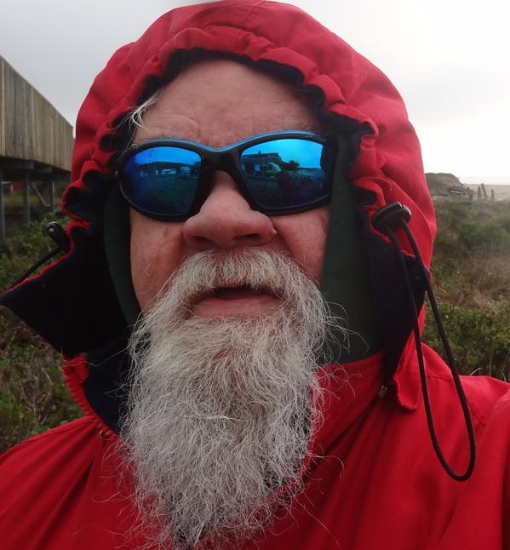
March 2014
Paul Winquist *Jan 8-1945 - still going), had a TV business in Las Vegas putting in TV systems into hotels, and casinos. This gave him an opportunity to meet many of the various figures in this appendix.


Photo by Paul Winquist
Becky Binion-Behnen -was my next-door neighbor in Las Vegas, and John ????? on the other. They purchased my house, (that had a club shaped swimming pool that was in Architectural Digest magazine,) to tear it down to expand their lots. The red roofed house in the background is Little Richard. (1910 Silver Ave. Las Vegas NV) PWW)
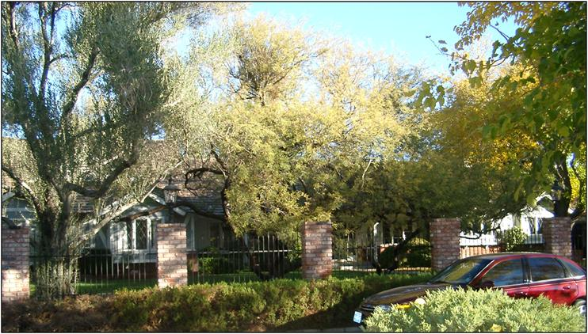
Moving In Day

Photo by Paul Winquist
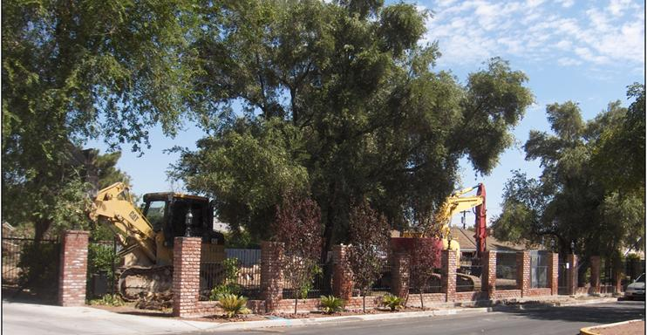
House is gone!

Photo by Paul Winquist

A new word for today's vocabulary
Ineptocracy (in-ept-o-cra-cy) - a system of government where the least capable to lead are elected by the least capable of producing, and where the members of society least likely to sustain themselves or succeed, are rewarded with goods and services paid for by the confiscated wealth of a diminishing number of producers.

I took a graduate course at PSU (Portland Oregon) in Artificial intelligence, and did a tremendous amount of reading on the topic. Also; a friend of mine is a physicist at Applied Materials, the company that makes the machines for Intel, Toshiba, LG, Sony, and so on.
In 4 1/2 years (2016) the cellphones will have over 200 of the 586 type computers in them, running very fast.
There are crews of medical people mapping the human brain with high resolution CAT scanners; this data is then passed on to crews that are mapping the genetic chain; so that people will be able to manipulate the genetic chain to create changes in the body or brain in a few years.
Also, in about 8-10 years the computers will be more powerful than a human brain and about 1/4 the physical size.
Simultaneously there are computer people connecting the nerve bundles to electronics and have put part of a rat brain into a robot; I watched the video of the rat-robot running around the floor trying to find a way out of the objects and the surrounding course they set up. (It's on U-tube)
Within about 8-10 years implants of computers into the frontal lobe of humans will allow them to do tremendous calculations, and communicate to the outside world via the internet and so on.
There is continual progress in implanting electronics in humans, for hearing, vision, and connecting up artificial limbs to the severed nerves.
So, the end result of evolution is transitioning from biological to electronics.
Already there are computers that are programmed by humans, to create better software than they themselves could write, and the resulting computers are designing better computers than humans can design.
It is already approaching the point where the governments should be replaced by computer systems, instead of the bickering lawyers/politicians.
Picture all the decisions being made for the good of all humans, based on logically calculated decisions based on real data, instead of self interests or religion.
In about 30 years the computers and robots will be so advanced that about a billion worthless humans can be eliminated; if the Christians and Muslims don't eliminate the humans first. PWW 2011)

Already:
Brain pacemakers for epilepsy, Parkinson's disease, major depression, and other diseases
Computer controlled pacemakers for hearts.
Implanted hearing aids for the totally deaf connected to the nerves,
TV cameras connected to the optic nerves bring limited vision to the totally blind.
Limbs controlled by the nerves for the physically disabled.
Implanted transponders for identification; mostly used for pets.

Hugo Chávez – President of Venezuela
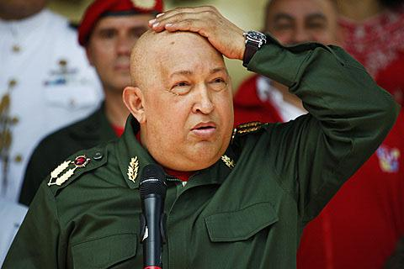
Cesar Chavez, President of Venezuela (Sept 11, 2011) – VOA (Voice of America) Photo
Hugo Rafael Chávez Frías born July 28, 1954 is the 56th and current President of Venezuela, having held that position since 1999. He was formerly the leader of the Fifth Republic Movement political party from its foundation in 1997 until 2007, when he became the leader of the United Socialist Party of Venezuela (PSUV). Following his own political ideology of Bolivarianism and "Socialism for the 21st Century", he has focused on implementing socialist reforms in the country as a part of a social project known as the Bolivarian Revolution, which has seen the implementation of a new constitution, participatory democratic councils, and the nationalization of several key industries.
Born into a working class family in Sabaneta, Barinas, Chávez became a career military officer, and after becoming dissatisfied with the Venezuelan puntofijismo political system which he viewed as corrupt and undemocratic, he founded the secretive Revolutionary Bolivarian Movement-200 (MBR-200) in the early 1980s to work towards overthrowing it. After the Democratic Action government of President Carlos Andrés Pérez ordered the violent repression of protests against spending cuts, Chávez led the MBR-200 in an unsuccessful coup d'état against the government in 1992, for which he was imprisoned.
Getting out of prison after two years, he founded a social democratic political party, the Fifth Republic Movement, and was elected president of Venezuela in 1998. He subsequently introduced a new constitution which increased rights for marginalized groups and altered the structure of Venezuelan government, and was re-elected in 2000. During his second presidential term, he introduced a system of Bolivarian Missions, Communal Councils and worker-managed cooperatives, as well as a program of land reform, whilst also nationalizing various key industries. The opposition movement meanwhile, arguing that he was a populist who was eroding representative democracy and becoming increasingly authoritative, attempted to remove him from power, both through an unsuccessful military coup in 2002, and a recall referendum in 2004. In 2005, he openly proclaimed his adherence to socialism, and was again elected into power in 2006, following which he founded his new political party, the PSUV, in 2007. Although suffering from cancer in 2011, Chávez has stated his intention to stand for re-election in 2012.
A self-professed anti-imperialist and vocal critic of neoliberalism and capitalism more generally, Chávez has been a prominent opponent of the United States' foreign policy. Allying himself strongly with the socialist governments of Fidel and then Raúl Castro in Cuba, Evo Morales in Bolivia, Rafael Correa in Ecuador, and Daniel Ortega in Nicaragua, his presidency is seen as a part of the leftist "pink tide" sweeping Latin America. He has supported Latin American and Caribbean cooperation and was instrumental in setting up the pan-regional Union of South American Nations, the Bolivarian Alliance for the Americas, the Bank of the South, and the regional television network TeleSur. A highly controversial and divisive figure both at home and abroad, his political influence in Latin America led Time Magazine to include him among their list of the world's 100 most influential people in both 2005 and 2006.

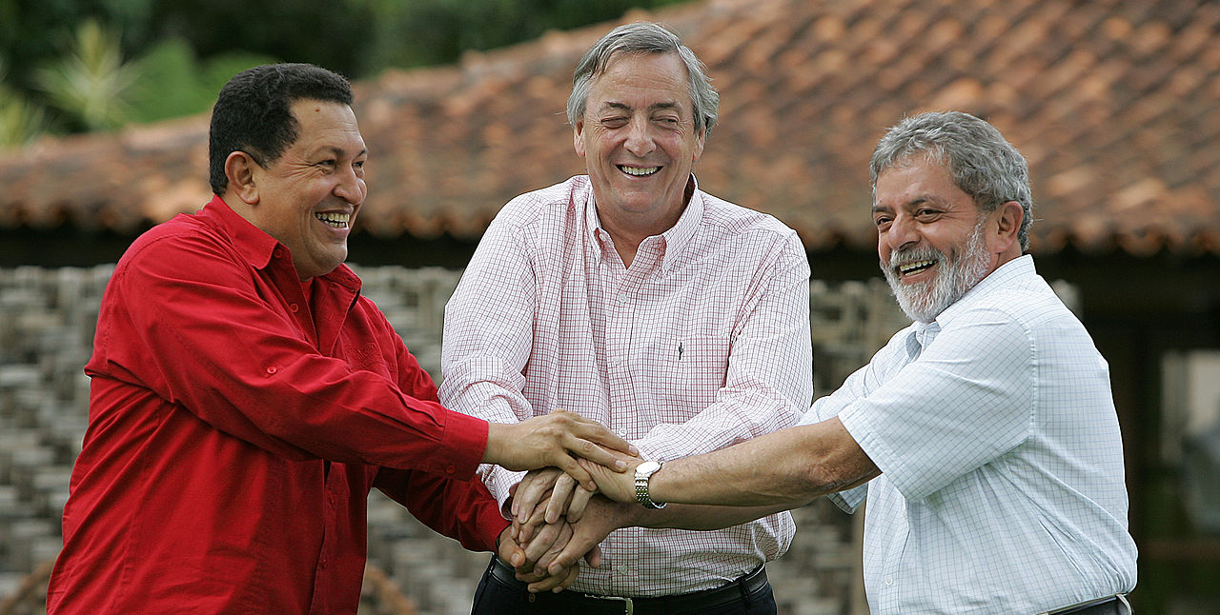
Chavez with fellow Latin American presidents of Argentina and Brazil.
The content of this website is published under the Creative Commons License Attribution 2.5 Brazil

